**Aggregate Demand and Aggregate Supply**

1. Assertion (A): Economy always operates on the level of full employment.

Reason (R): Due to changes in the aggregate demand, full employment may not always exist.

(a) Both Assertion (A) and Reason (R) are true and Reason (R) is the correct explanation of Assertion (A).

(b) Both Assertion (A) and Reason (R) are true and Reason (R) is not the correct explanation of Assertion (A).

(c) Assertion (A) is true but Reason (R) is false.

(d) Assertion (A) is false but Reason (R) is true.

Ans. (d) Assertion (A) is false but Reason (R) is true.

2. Assertion (A): In case of deficient demand, government must decrease the rate of taxes in the economy.

Reason (R): Taxes affect the disposable income and purchasing power of general public in the economy.

(a) Both Assertion (A) and Reason (R) are true and Reason (R) is the correct explanation of Assertion (A).

(b) Both Assertion (A) and Reason (R) are true and Reason (R) is not the correct explanation of Assertion (A).

(c) Assertion (A) is true but Reason (R) is false.

(d) Assertion (A) is false but Reason (R) is true.

Ans. (a) Both Assertion (A) and Reason (R) are true and Reason (R) is the correct explanation of Assertion (A).

3. Assertion (A) : Savings curve is a straight line.

Reason (R): As income increases, consumer starts savings more.

(a) Both Assertion (A) and Reason (R) are correct and Reason (R) is the correct explanation of Assertion (A).

(b) Both Assertion (A) and Reason (R) are correct and Reason (R) is not the correct explanation of Assertion (A).

(c) Assertion (A) is true but Reason (R) is false.

(d) Assertion (A) is false but Reason (R) is true.

Ans. (a) Both Assertion (A) and Reason (R) are correct and Reason (R) is the correct explanation of Assertion (A).

4. Statement 1: Consumption curve is upward sloping because MPC is constant.

Statement 2: Aggregate Demand and Consumption Curve are parallel to each other.

(a) Both the statements are correct.

(b) Both the statements are incorrect.

(c) Statement 1 is correct and statement 2 is incorrect.

(d) Statement 1 is incorrect and statement 2 is correct.

Ans. (d) Statement 1 is incorrect and statement 2 is correct.

5. Statement 1: Value of APS is 1 at break-even level of income.

Statement 2: Savings curve starts from negative point on Y axis.

(a) Both the statements are correct

(b) Both the statements are incorrect.

(c) Statement 1 is correct and statement 2 is incorrect.

(d) Statement 1 is incorrect and statement 2 is correct.

Ans. (d) Statement 1 is incorrect and statement 2 is correct.

6. Statement 1: Aggregate Demand Curve starts from a positive point on X axis.

Statement 2: Investments and consumption curve are parallel to each other.

(a) Both the statements are correct.

(b) Both the statements are incorrect.

(c) Statement 1 is correct and statement 2 is incorrect.

(d) Statement 1 is incorrect and statement 2 is correct.

Ans. (b) Both the statements are incorrect.

7. Assertion (A): APS is a flow concept.

Reason (R): APS is the ratio of savings to income at a particular point of time.

(a) Both Assertion (A) and Reason (R) are correct and Reason (R) is the correct explanation of Assertion (A).

(b) Both Assertion (A) and Reason (R) are correct and Reason (R) is not the correct explanation of Assertion (A).

(c) Assertion (A) is true but Reason (R) is false.

(d) Assertion (A) is false but Reason (R) is true.

Ans. (d) Assertion (A) is false but Reason (R) is true.

8. Assertion (A): Full Employment does not indicate the situation of zero employment in the economy.

Reason (R): Voluntary Unemployment prevails in the economy always because it refers to those unemployed people who are able to work but not willing to work at a given wage rate.

(a) Both Assertion (A) and Reason (R) are correct and Reason (R) is the correct explanation of Assertion (A).

(b) Both Assertion (A) and Reason (R) are correct and Reason (R) is not the correct explanation of Assertion (A).

(c) Assertion (A) is true but Reason (R) is false

(d) Assertion (A) is false but Reason (R) is true.

Ans. (a) Both Assertion (A) and Reason (R) are correct and Reason (R) is the correct explanation of Assertion (A).

9. Statement 1: Underemployment equilibrium leads to inflationary gap in the economy.

Statement 2: Deficient Demand is the situation where AD is less than AS at a level of full employment.

(a) Both the statements are correct.

(b) Both the statements are incorrect.

(c) Statement 1 is correct and statement 2 is incorrect.

(d) Statement 1 is incorrect and statement 2 is correct.

Ans. (d) Statement 1 is incorrect and statement 2 is correct.

10. Statement 1: Value of APC at equilibrium level in the economy is always 1.

Statement 2: When C = 100+ 0.80 Y, consumption curve starts from point of origin.

(a) Both the statements are correct.

(b) Both the statements are incorrect.

(c) Statement 1 is correct and statement 2 is incorrect.

(d) Statement 1 is incorrect and statement 2 is correct.

Ans. (b) Both the statements are incorrect.

11. Draw on a diagram a straight-line savings curve for an economy. From it derive the consumption curve, explaining the method of derivation. Show a point on the consumption curve at which average propensity to consume is equal to 1.

Ans. In the given diagram, SS' is the saving curve which shows negative savings equal to OS at zero level of income and zero saving at OA level of income.

* At zero level of income, consumption expenditure is equal to OC which is equal to negative saving of OS at that level of income. So, C is the starting point of consumption curve.
* Savings are zero at OA level of income as the whole of income is spent. So, at OA level of income, consumption expenditure must be equal to OD = OA. This gives a point B on the consumption curve.

By joining C and B and extending it further, we get consumption curve. At point B on the consumption curve, total consumption expenditure (C) is equal to total income (Y). So, C/Y = 1. Hence, at point B, on consumption curve, APC = 1.

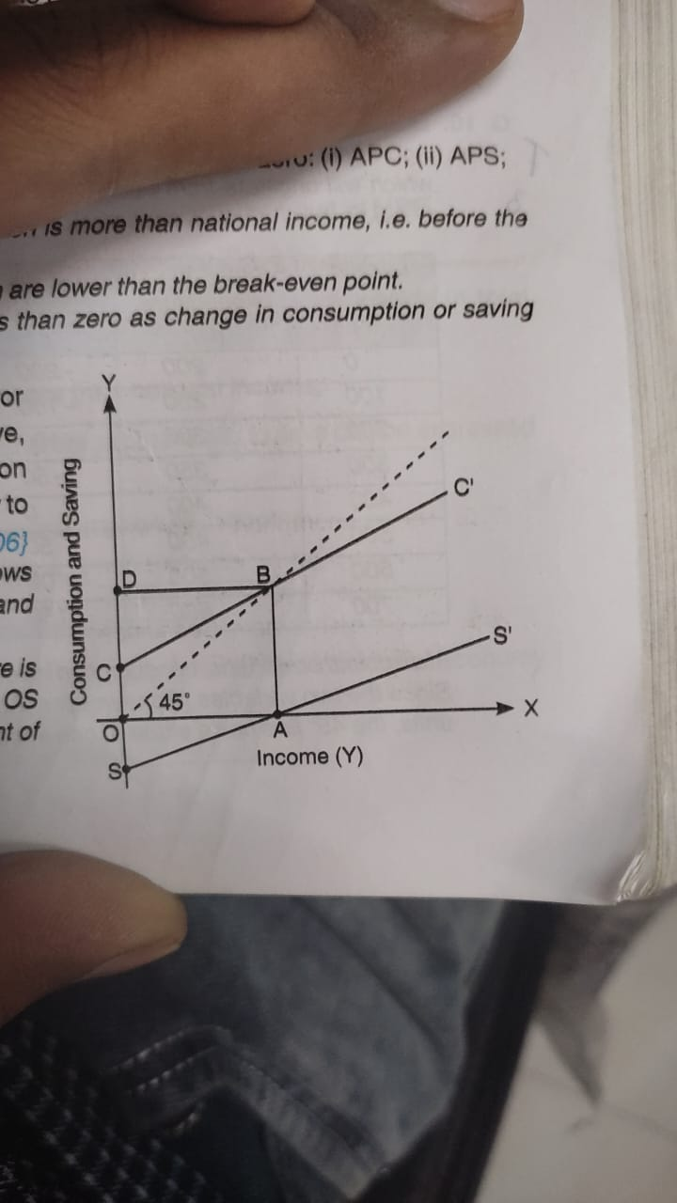

12. Distinguish between voluntary unemployment and involuntary unemployment. What is the significance of this distinction?

Ans. Voluntary unemployment refers to a situation when a person is unemployed because he is not willing to work at the existing wage rate. On the other hand, Involuntary unemployment refers to an unemployment in which all those people, who are willing and able to work at the existing wage rate, do not get work. The distinction is significant to determine the total unemployment in an economy Voluntary unemployment is not counted while estimating the size of unemployment. While involuntary unemployment is considered while estimating the total unemployment in an economy.

13. Discuss the significance of 45° line in Keynesian Economics.

Ans. Aggregate Supply is obtained by adding consumption and saving schedules. The straight line obtained which will originate from point of origin will form a 45° angle there by establishing the relation of Y = C+S.

|  |  |  |  |
| --- | --- | --- | --- |
| Level of Income (Y) | Consumption Expenditure (C) | Saving (Y – C) | Y = AS = C + S |
| 0 | 200 | -200 | 0 |
| 100 | 250 | -150 | 100 |
| 200 | 300 | -100 | 200 |
| 300 | 350 | -50 | 300 |
| 400 | 400 | 0 | 400 |
| 500 | 450 | 50 | 500 |
| 600 | 500 | 100 | 600 |
| 700 | 600 | 150 | 700 |

At all points on 450 line, consumption is equal to income. It helps under the Keynesian Economic analysis. Since the two variables (Consumption/Aggregate Expenditure and Income) are measured in the same units, the 450 line has a slope of one and it bisects the 90° angle formed by the two axes.

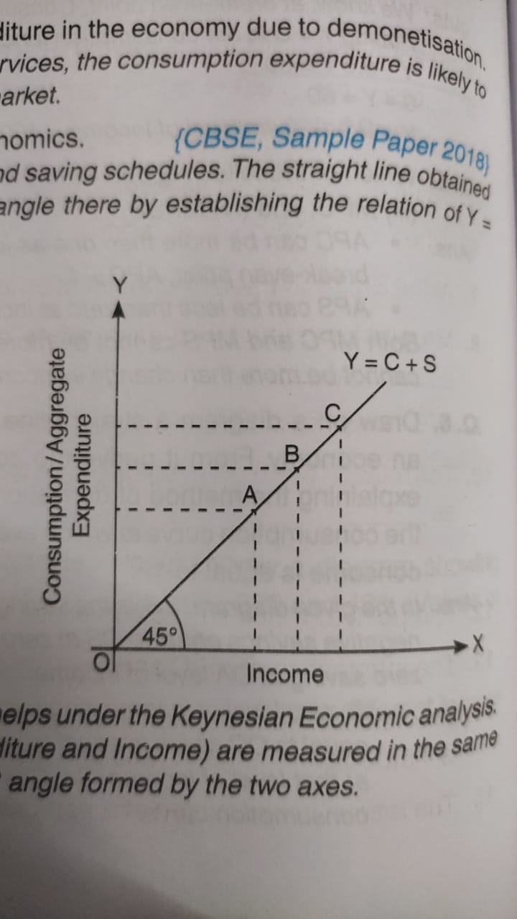

14. What is ex-ante consumption? Distinguish between autonomous consumption and induced consumption.

Ans. Ex-ante consumption refers to the consumption expenditure planned to be incurred during a period. Autonomous Consumption refers to the consumption expenditure which does not depend upon the level of income, i.e. the consumption at zero level of income.

Whereas, Induced Consumption expenditure is directly determined by the level of income.

**State True of False with valid reason**:

15. Value of average propensity to save can never be less than zero.

OR

Average propensity to save is always greater than zero.

OR

Average propensity to save can never be negative.

Ans. False APS can be negative at low level of income when consumption expenditure is greater than income.

16. When the value of average propensity to save is negative, the value of marginal propensity to save will also be negative.

Ans. False. The value of MPS can never be negative. It varies between 0 and 1.

17. The value of average propensity to save can never be greater than 1.

Ans. True. Average propensity to save can never be greater than 1 as savings can never be more than national income.

18. Sum of average propensity to consume and marginal propensity to consume is always equal to 1.

Ans. False. There is no such relation between average propensity to consume (APC) and marginal propensity to consume (MPC). APC is the ratio of consumption and income while MPC is the ratio of change in consumption and change in income.

19. Value of marginal propensity to consume can be greater than one.

Ans. False. It is not possible as change in consumption cannot be more than change in income.

20. Average propensity to consume can be greater than one.

Ans. True. Average propensity to consume can be greater than one when consumption is greater than income.

21. According to Keynesian theory of employment, Ex-Ante savings and Ex-post savings are always equal.

Ans. False. Ex-ante savings are those which all the households plan to make at different level of income during a period, whereas ex-post savings are the actual amount of savings made in the economy during a period. So, the two may or may not be equal.

22. Ex-post investment means fixed capital with production units during a particular period of time.

False. As ex-post investment includes both fixed as well as inventory investment with the production unit during a period of time.

23. In a two-sector economy, if consumption is equal to income, average propensity to save will be zero.

Ans. True. If consumption and income are equal, savings will be zero. Hence, APS = S/Y = 0/Y = zero

24. Marginal Propensity to Consume represents the slope of the consumption function.

Ans. True. As Marginal Propensity to Consume (MPC) represents change in consumption due to a given change in income. MPC (∆C/∆Y).

25. Suppose in a hypothetical economy, the income rises from ₹ 5,000 crores to ₹ 6,000 crores. As a result, the consumption expenditure rises from ₹ 4,000 crores to ₹ 4,600 crores. Marginal propensity to consume in such a case would be _______________ . (Choose the correct alternative)

(a) 0.8 (b) 0.4 (c) 0.2 (d) 0.6

Ans. (d) 0.6

26. Average Propensity to Consume can never be _____________.

(a) positive (b) zero (c) more than one (d) less than one

Ans. (b) zero

27. Can the value of average propensity to save be negative? If yes, when?

Ans. Yeas, value of average propensity to save can be negative when consumption is more than national income, i.e. before break-even point.

28. What is the relationship between marginal propensity to save and marginal propensity to consume?

Ans. The sum total of MPC and MPS is equal to one, i.e., MPC + MPS = 1.

29. Give the meaning of autonomous consumption.

Ans. It refers to minimum level of consumption, which is needed for survival, i.e. consumption at zero level of national income.

30. Why does consumption curve not start from the origin.

Ans. Consumption curve does not start from the origin because it includes autonomous consumption (i.e. minimum consumption requirement) and autonomous consumption is never zero.

31. Can APC be ever zero?

Ans. APC can never be equal to zero as consumption can never be zero at any level of income.

32. (i) The disposable income (Y) is ₹ 1200 crores and consumption expenditure (C) is ₹ 800 crores. Calculate the APC.

(ii) If saving is ₹ 500, out of an income of ₹ 5,000, how much is the APS?

(iii) If disposable income is ₹ 1,000 and consumption expenditure is ₹ 750, find out average propensity to save.

(iv) If income is ₹ 500 and saving are ₹ 100, calculate APC.

(v) When income rises from ₹ 1,000 to ₹ 1,100, saving rise by ₹ 30. Find out MPS and MPC.

Solution:

(i) APC = $\frac{Consumption (C) }{Income (Y)}= \frac{800}{1,200}$ = 0.67

(ii) APS = $\frac{Saving (S) }{Income (Y)}$ = $\frac{500}{5,000}$ = 0.10

(iii) APS = $\frac{Saving (S) }{Income (Y)}$ = $\frac{1,000 - 750}{1,000}$ = 0.25

(iv) APC = $\frac{Consumption (C) }{Income (Y)}= \frac{500-100}{500}$ = 0.80

(v) MPS = $\frac{Change in Saving (∆S) }{Change in Income (∆ Y) }$ = $\frac{30}{1,100-1,000}$ = 0.30

MPC = 1-MPS = 1-0.30= 0.70

33. Calculate the value of MPS from the given table:

|  |  |  |  |  |  |
| --- | --- | --- | --- | --- | --- |
| Income (₹) | 100 | 200 | 300 | 400 | 500 |
| Saving (₹) | 15 | 40 | 70 | 110 | 160 |

Solution:

|  |  |  |  |  |
| --- | --- | --- | --- | --- |
| Income (Y) (₹) | Saving (S) (₹) | Change in Saving (∆S) (₹) | Change in Income (∆Y) (₹) | MPS  MPS = ∆S/∆Y |
| 100 | 15 | -- | -- | -- |
| 200 | 40 | 25 | 100 | 0.25 |
| 300 | 70 | 30 | 100 | 0.30 |
| 400 | 110 | 40 | 100 | 0.40 |
| 500 | 160 | 50 | 100 | 0.50 |

34. Complete the following table:

|  |  |  |  |
| --- | --- | --- | --- |
| Income | Saving | Marginal Propensity to Consume | Average Propensity to save |
| 0 | -12 | -- | -- |
| 20 | -6 | -- | -- |
| 40 | 0 | -- | -- |
| 60 | 6 | -- | -- |

Solution:

|  |  |  |  |  |
| --- | --- | --- | --- | --- |
| Income (Y) (₹) | Saving (S) (₹) | Consumption (C) (₹) | Marginal Propensity to Consume (MPC)  MPC = ∆C/∆Y | Average Propensity to save (APS)  APS = S/Y |
| 0 | -12 | 12 | -- | -- |
| 20 | -6 | 26 | 0.70 | -0.30 |
| 40 | 0 | 40 | 0.70 | 0.00 |
| 60 | 6 | 54 | 0.70 | 0.10 |

36. Complete the following table:

|  |  |  |  |
| --- | --- | --- | --- |
| Income (Y) (₹) | Marginal Propensity to Consume (MPC) | Saving (S) (₹) | Average Propensity to save (APS)  APS = S/Y |
| 0 | -- | -90 | -- |
| 100 | 0.6 | -- | -- |
| 200 | 0.6 | -- | -- |
| 300 | 0.6 | -- | -- |

Solution:

|  |  |  |  |  |  |
| --- | --- | --- | --- | --- | --- |
| Income (Y) (₹) | MPC | MPS  MPS = 1 – MPC | ∆S = MPS X ∆Y | Saving (S) (₹) | APS  APS = S/Y |
| 0 | -- | -- | -- | -90 | -- |
| 100 | 0.6 | 0.4 | 40 | -50 | -0.50 |
| 200 | 0.6 | 0.4 | 40 | -10 | -0.05 |
| 300 | 0.6 | 0.4 | 40 | 30 | 0.10 |

37. Given that national income is ₹ 80 crore and consumption expenditure ₹ 64 crore, find out average propensity to save. When income rises to ₹ 100 crore and consumption expenditure to ₹ 78 crore, what will be the average propensity to consume and the marginal propensity to consume?

Ans. APS = $\frac{Saving (S) }{Income (Y)}$ = $\frac{80 - 64}{80}$ = 0.20

When income rises to ₹ 100 crore and consumption expenditure to ₹ 78 crore

Average Propensity to consume = $\frac{Consumption (C) }{Income (Y)}=\frac{78}{100}$ = 0.78

Marginal Propensity to consume = = 0.70

38. Given below is the consumption function of an economy:

C = 100 + 0.5Y

With the help of a numerical example, show that in this economy, as income increases, APC will decrease.

Solution:

Given consumption function: C = 100 + 0.5Y

To show that APC decreases with increase in income, consider the following hypothetical schedule:

|  |  |  |
| --- | --- | --- |
| Income (Y) (₹) | Consumption (C) (₹)  C = 100 + 0.5Y | APC  APC = C/Y |
| 100 | 150 (=100/0.5 x 100) | 1.50 (=150/100) |
| 200 | 200 (=100/0.5 x 200) | 1 (=200/200) |
| 300 | 250 (=100/0.5 x 300) | 0.83 (=250/300) |
| 400 | 300 (=100/0.5 x 400) | 0.75 (=300/400) |
| 500 | 350 (=100/0.5 x 500) | 0.70 (=350/500) |

As seen in the given schedule, when the income increases from ₹ 100 crores to ₹ 200 crores and then to ₹ 300 crores and so on, APC decreases from 1.5 to 1 and then to 0.83 and keeps on decreasing with increase in income. Therefore, with an increase in income, APC decreases.

39. If a consumption function of a hypothetical economy is given as:

C = 100 + 0.6Y then

(i) What will be the values of marginal propensity to consume and marginal propensity to save for the economy?

(ii) Write the corresponding saving function.

Solution:

(i) C=100 + 0.6Y (given)

So, MPC = 0.6

MPS = 1 – MPC = 1 - 0.6 = 0.4

(ii) S = - C + (1 - b)/ Y

S = - 100 + 0.4Y

40. Estimate the value of Aggregate Demand in an economy if:

(a) Autonomous Investment (I) = 100 Crores

(b) Marginal Propensity to Save = 0.2

(c) Level of Income (Y) = 4,000 crores

(d) Autonomous Consumption Expenditure (c) = 50 crores

Solution:

Aggregate Demand (AD) function is given as: AD = C + I

or, AD = {c +b(Y)}+I

C = 50 (Given)

b or MPC = 1 – MPS = 1 - 0.2 = 0.8

Substituting the values of c and b in AD function,

we get: AD = (50 + 0.8(4000)) + 100 = 3,350 crores

Aggregate Demand = 3,350 crores

41. In an economy, the equilibrium level of income is ₹ 12,000 crore. The ratio of marginal propensity to consume and marginal propensity to save is 3:1. Calculate the additional investment needed to reach a new equilibrium level of income of ₹ 20,000 crore.

Solution:

Ratio of 3:1 between marginal propensity to consume (MPC) and marginal propensity to save

(MPS) signifies: MPC = 3/4 or 0.75 and MPS = 1/4 or 0.25.

Multiplier (k) = 1/MPS = 1/0.25 = 4

We also know: k = $\frac{Change in Income (∆ Y) }{Change in Investment (∆ l)}$

Given: Change in Income (∆ Y) = 20,000 - 12,000 = 8,000 crores

i.e., 4 = $\frac{8,000 }{Change in Investment (∆ l)}$

Hence, Change in Investment ($∆$ I) = 2,000 crores

Additional investment needed is 2,000 crores

42. In an economy, marginal propensity to consume is 0.75. If investment expenditure is increased by 500 crores, calculate the total increase in income and consumption expenditure.

Ans. Multiplier (k) = $\frac{1}{1-MPC }$ = $\frac{1}{1-0.75 }$ = 4

We also know: k = $\frac{Change in Income (∆ Y) }{Change in Investment (∆ l)}$

4 = Change in Income (∆ Y)/500

So. Change in Income (∆ Y) = 2,000 crores

MPC = Change in Consumption (∆ C)/Change in Income (∆ Y)

0.75 = Change in Consumption (∆ C)/2,000

So, Change in Consumption (∆ C) = ₹ 1,500 crores

Ans. Total increase in income = 2,000 crores; Total increase in Consumption Expenditure = 1,500 crores

43. An increase of ₹ 200 crore in investment leads to a rise in national income by ₹ 1,000 crores. Find out marginal propensity to consume.

Ans. Multiplier (k) = Change in Income (∆ Y)/Change in Investment (∆ I) = 1,000/200 = 5

We know, Multiplier (k )= 1/(1 - MPC)

5 = 1/(1 - MPC)

1 - MPC = 1/5

Hence, MPC = 1 - 0.20 = 0.80

Ans. Marginal Propensity to Consume (MPC) = 0.8

44. As a result of increase in investment by ₹ 125 crores, national income increase by ₹ 500 crores. Calculate marginal propensity to consume.

Ans. Multiplier (k) = Change in Income (∆ Y)/Change in Investment (∆ I) = 500/125 = 4

We know, Multiplier (k )= 1/(1 - MPC)

4 = 1/(1 - MPC)

1 - MPC = ¼

MPC = 1 – 0.25 = 0.75

45. In an economy, investment is increased by 300 crore. If marginal propensity to consume is 2/3, calculate increase in national income.

Ans. Multiplier (k) = 1/(1 - MPC) = 1/(1 – 2/3) = 3

We also know, k = Change in Income (∆ Y)/Change in Investment (∆ I)

3 = Change in Income (∆ Y)/300

Hence, Increase in National Income (∆ Y) = 900 crores

Ans, Increase in National Income = 900 crores

46. If marginal propensity to consume is 0.9, what is the value of multiplier? How much investment is needed, if national income increases by ₹ 5,000 crores?

Ans. Multiplier (k) = 1/1-MPC = 1 - 0.90= 1/ 0.10 = 10

We also know: k = Change in Income (∆ Y)/Change in Investment (∆ I)

10 = 5,000/Change in Investment (∆ l)

Hence, Change in Investment (∆ l) = 500 crores

Ans. Multiplier (k) = 10 ; Increase in investment = 500 crores

47. In an economy 75 percent of the increase of income is spent on consumption. Investment is increased by ₹ 1,000 crore. Calculate (a) total increase in income; (b) total increase in consumed expenditure.

Ans. Given: MPC = 0.75 (as 75% of increase in income is spent on consumption)

Multiplier (k) = 1/1-MPC = 1/1-0.75 = 0.25

When also know: k = Change in Income (∆ Y)/Change in Investment (∆ I)

4 = Change in Income (∆ Y)/1,000

So, Change in Income (∆ Y) = 4,000 crores

MPC = Change in Consumption (∆ C)/Change in Income (∆ Y)

0.75 = Change in Consumption (∆ C)/4,000

So, Change in Consumption (∆ C) = 3,000 crores

Ans. Total increase in income = ∆ 4,000 crores; Total increase in Consumption Expenditure = 3,000 crores

48. An increase of ₹ 250 crores in investment in an economy resulted in total increase in income of ₹ 1,000 crores. Calculate the following: (a) Marginal propensity to consume (MPC), (b) Change in Saving, (c) Change in consumption expenditure, (d) Value of multiplier.

Solution:

k = Change in Income (∆ Y)/Change in Investment (∆ I) = 1,000/250 = 4

We know, Multiplier (k) = 1/1-MPC

4 = 1/1-MPC

1- MPC = 1/4

Hence, MPC = 1 - 0.25 = 0.75

MPC = Change in Consumption (∆ C)/Change in Income (∆ Y)

0.75 = Change in Consumption (∆ C)/1,000

So, Change in Consumption Expenditure (∆ C) = 750 crores.

Change in Saving = Change in Income - Change in Consumption Expenditure

So, Change in Saving = 1,000 crores – 750 crores = 250 crores

Ans. (a) Marginal propensity to consume= 0.75; (b) Change in Saving 250 crores;

(c) Change in consumption expenditure = 750 crores; (d) Value of multiplier = 4

49. In an economy, income increases by 10,000 as a result of a rise in investment expenditure by 1,000. Calculate: (a) Investment Multiplier; (b) Marginal Propensity to Consume.

Solution:

(a) Investment Multiplier (k) = Change in Income (∆ Y)/Change in Investment (∆ I) = 10,000/1,000 = 10

(b) We know, k = 1/1-MPC

10 = 1/1-MPC

MPC = 1 - 0.10 = 0.9

Ans. (a) Investment Multiplier = 10; (b) Marginal Propensity to Consume (MPC) = 0.9

50. In an economy, an increase in investment leads to increase in national income which is three times more than the increase in investment. Calculate marginal propensity to consume.

Ans. Let increase in Investment = ∆ l

Then, increase in national income = ∆ l + 3 ∆ l = 4 ∆ l

Investment Multiplier (k) = Increase in Income/Increase in Investment = 4 ∆ l/∆ l = 4

We know, k = 1/1-MPC

4 = 1/1-MPC

Hence, MPC = 1 - 0.25 = 0.75

Marginal Propensity to Consume (MPC) = 0.75

51. In an economy, with every increase in income, 10 per cent of the rise in income is saved. Suppose a fresh investment of ₹ 120 crores takes place in the economy. Calculate the following: (i) Change in the income; (ii) Change in consumption.

Ans.

Given: MPS = 0.10

Multiplier (k) = 1/MPS = 1/0.10 = 10

We also know: k = Change in Income (∆ Y)/Change in Investment (∆ I)

10 = Change in Income (∆ Y)/120

So, Change in Income (∆ Y) 1= ,200 crores

MPC = Change in Consumption (∆ C)/Change in Income (∆ Y)

0.90 = Change in Consumption (∆ C)/1,200

So, Change in Consumption (∆ C) = 1,200 x 0.90 = 1,080 crores

Ans. (i) Change in the income =1,200 crores; (ii) Change in consumption = 1,080 crores.

52. Given consumption function C-100 + 0.75Y (where C = consumption expenditure and Y national income) and investment expenditure 1,000, calculate: (i) Equilibrium level of national income; (ii) Consumption expenditure at equilibrium level of national income.

Solution:

(i) Equilibrium level of National Income (Y)

At Equilibrium, Y = C + I

Or, Y = 100 + 0.75 + 1,000

0.25Y = 1,100

Y = 4,400

(ii) Consumption expenditure at equilibrium level of national income.

Putting value of National Income of 4,400 in consumption function, we get:

C = 100 + 0.75 x 4,400

C = 3,400

Ans. (i) Equilibrium level of national income 4,400; (ii) Consumption expenditure at equilibrium level of national income = 3,400

53. In an economy, the consumption function is C = 500 + 0.75Y, where C is consumption expenditure and Y is income. Calculate the equilibrium level of income and consumption expenditure, when investment expenditure is 5,000.

Ans.

(i) Equilibrium level of National Income (Y)

At Equilibrium, Y = C+I

Or, Y = 500 + 0.75Y + 5,000

0.25Y = 5,500

Y = 22,000

(ii) Consumption expenditure at equilibrium level of national income.

Putting value of National Income of 22,000 in consumption function, we get:

C = 500 + 0.75 x 22,000

C = 17,000

Ans. Equilibrium level of income = 22,000; Consumption expenditure at equilibrium level of income = 17,000.

54. The saving function of an economy is S = - 200 + 0.25Y. The economy is in equilibrium when income is equal to 2,000. Calculate: (a) Investment expenditure at equilibrium level of income; (b) Autonomous consumption; (c) Investment multiplier.

Ans. (a) Investment expenditure at equilibrium level of income

Given, Equilibrium Level of Income (Y)=2,000. Putting value of Y in saving function, we get:

S = - 200 + 0.25 × 2,000 = 300

At equilibrium, Planned Saving (S) = Planned Investment (I). It means:

Investment expenditure (I) at equilibrium level of income = 300

(b) Autonomous consumption

We know, Consumption (C)+ Saving (S) = Income (Y)

Autonomous consumption means the level of consumption expenditure when income is zero.

When Y = 0; Saving = - 200, So, autonomous consumption = 200

(Alternately, autonomous consumption can also be calculated from the saving function. We know Saving function is expressed as: S = C +Y (1-b). It means, -200 indicates that autonomous consumption (c) = 200)

(c) Investment Multiplier

From the saving function, we know that MPS = 0.25

Investment Multiplier (k) = 1/MPS = 1/0.25 = 4

Ans. (a) Investment expenditure at equilibrium level of income = 300; (b) Autonomous consumption= 200; (c) Investment multiplier = 4

55. Find national income from the following:

Autonomous consumption 100

Marginal propensity to consume 0.80

Investment 50

Ans. We know: National Income (Y) = Consumption (C) + Investment (I)

Consumption Function is given as: C = c + b(Y)

So, Y = c + b(Y) + I

Putting the values of c, b and I, we get:

Y = 100 + 0.8Y + 50

0.2Y = 150

National Income (Y) = 750

56. The saving function of an economy is given as: S = -25+0.25 Y. If the planned investment is 200 crores, calculate the following: (i) Equilibrium level of income in the economy. (ii) Aggregate demand at income of 500 crores.

Ans. (i) We know that the equilibrium level of income in an economy is determined when: S = I.

According to the question:

200 = - 25 +0.25Y

225 = 0.25Y

Y = 900 crores.

(ii) We know that in an economy: AD = C + I. Also, C = 25+ (1 – 0.25) Y

According to the question, AD at income of 500 crores will be:

AD = 25 + (1 - 0.25) Y+200

AD = 25 + 0.75 (500) + 200

AD = 600 crores.

57. The saving function of an economy is given as: S = (-) 10 + 0.20 Y. If the ex-ante investments are 240 crores, calculate the following: (i) Equilibrium level of income in the economy. (ii) Additional investments which will be needed to double the present level of equilibrium income.

(i) We know that the equilibrium level of income in an economy is determined when: S = I.

According to the question: 240 = - 10 + 0.20Y

250 = 0.20Y

Y = 1,250 crores.

(ii) Given Equilibrium Level of Income = ₹ 1,250 crores. To double this existing income level, we need additional income of ₹ 1,250 crores, i.e. ∆ Y = ₹ 1,250 crores. To calculate the additional investments (∆ I), we first need to calculate Investment Multiplier (k).

Investment Multiplier (k) = 1/MPS = 1/0.20 = 5

We also know: k = Change in Income (∆ Y)/Change in Investment (∆ I)

Change in Investment (∆ I) = 1250/5

Change in Investment (∆ I) = ₹ 250 crores

58. Calculate the value of Marginal Propensity to Consume (MPC), if in an economy, autonomous consumption is ₹ 500 crores, ex-ante investments are ₹ 4,000 crores and equilibrium level of Income of the economy is ₹ 18,000 crores.

Solution:

Given, Autonomous Consumption (c) = ₹ 500 crores and Ex-ante Investments (I)= ₹ 4,000 crores

We know that consumption function is: C = c + MPC. Y ………….(1)

At equilibrium level of Income in the economy, Y= C + I or C = Y - I …………..(2)

Putting value of C from (2) in (1), we get: Y – I = C + MPC.Y

18,000 - 4,000 = 500 + MPC (18,000)

14,000 - 500 = MPC (18,000)

MPC (18,000) = 13,500

MPC = 13,500/18,000

MPC = 0.75

59. On the basis of following schedule, answer the given questions:

|  |  |
| --- | --- |
| Income (in ₹ crores) | Savings (in ₹ crores) |
| 0 | -20 |
| 50 | -10 |
| 100 | 0 |
| 150 | 30 |
| 200 | 60 |

(a) Calculate Marginal Propensity to Save (MPS) at ₹ 150 crores level of income. [1]

(b) What is the value of Autonomous Consumption? [1]

OR

In an economy 75 percent of the increase in income is spent on consumption. Investment increased by ₹ 1,000 crore. Calculate the total increase in income on the basis of given information. [2]

Ans.

|  |  |  |  |
| --- | --- | --- | --- |
| (Y) (in crores) | (S) (in crores) | ∆ S (in crores) | ∆ Y (in crores) |
| 0 | - 20 | -- | -- |
| 50 | - 10 | -10 – (-20) = 10 | 50 – 0 = 50 |
| 100 | 0 | 0 – (-10) = 10 | 100 – 50 = 50 |
| 150 | 30 | 30 – 0 = 30 | 150 – 100 = 50 |
| 200 | 60 | 60 – 30 = 30 | 200 – 150 = 50 |

(a) MPS at 150 = $\frac{∆ S}{∆ Y}$ = $\frac{30}{50}$ = 0.6

(b) Autonomous consumption (consumption at 0 level of income) Y - S = 0 - (- 20) = 20 crores.

OR

MPC = 75% = 0.75

∆ I = 1,000

∆ Y = ?

K = $\frac{1}{1-MPC}$

= $\frac{1}{1-0.75}$ = $\frac{1}{0.25 }$ = 4

K = $\frac{∆ Y}{∆ I}$

4 = $\frac{∆ Y}{1000}$

4 X 1000 = ∆ Y

4,000 = ∆ Y

Thus, the increase in income = ₹ 4,000 crores

60. Excess demand greater opportunities of employment in the economy' Defend or refute the given statement with valid explanation. [2]

Ans. I refute the given statement.

Reasons:

1. Excess demand (AD > AS at full employment level) occurs after an economy achieves full employment level.

2. Excess Demand puts pressure on the available stock of goods which leads to increase in price level only (inflationary gap).

If all the resources are already fully employed, there is no scope of more opportunities of employment in the economy.

61. If in an economy Bank rate is increased, how will it affect the demand for credit? Explain. [3]

Ans. Bank Rate: It is the rate of interest at which Central bank of a country gives loan to the Commercial banks for long period.

Effect of Increase in Bank Rate on Credit:

1. Central Bank increases bank rate at the time of excess demand in the economy.

2. As a follow up action, Commercial banks increase lending rates.

3. Due to this, credit becomes dearer.

4. Thus, it leads to fall in demand for credit.

62. State and discuss any two monetary tools to control inflationary pressures in the economy. [5]

Ans. Monetary tools to control Inflationary pressure:

1. Statutory Liquidity Ratio (SLR): It refers to a certain percentage of total deposits of a commercial bank, which it requires to maintain with itself in liquid form.

(i) SLR is increased to control inflation.

(ii) It leads to fall in credit capacity of commercial banks.

(iii) Thus, credit contracts and fall in Aggregate Demand.

(iv) Fall in AD leads to fall in prices.

2. Cash Reserve Ratio (CRR): It refers to a certain percentage of total deposits of a commercial bank, which it requires to maintain with RBI.

(i) CRR is increased to control inflation.

(ii) It leads to fall in credit capacity of commercial banks.

(iii) Thus, credit contracts and fall in Aggregate Demand.

(iv) Fall in AD leads to fall in prices.

63. Explain the role of legal reserve ratio and Bank rate in correcting inflationary gap in an economy. [5]

Ans. Legal Reserve Ratio or LRR refers to a portion of the total deposits of a commercial bank which it has to keep with the central bank or with itself in the form of cash, marketable securities or gold. There are two components of LRR, i.e., (i) Cash Reserve Ratio (CRR) and (ii) Statutory Reserve Ratio (SLR). The bank rate, also known as the rediscount rate is the rate a at which the central bank extends loan to commercial banks or rediscounts the commercial bills brought by the commercial banks in the case of financial need.

As far as LRR is concerned, the loanable capacity of a commercial bank gets reduced by the amount of LRR. By increasing the LRR, the excess reserve of the commercial bank is reduced which restricts the credit-granting capacity of the commercial bank. Similarly, when the bank rate is raised, the loan becomes costlier for the commercial banks which also raise interest rates on loans for general customer. The rise in both these reduces the aggregate demand and the inflationary gap.

64. Explain the role of Repo rate and Reverse Repo rate in correcting deflationary gap in an economy. [5]

Ans. Repo Rate refers to the repurchase rate. This is the rate of interest at which the commercial banks borrow money from the Central bank against securities with the promise to buy them back after a certain time period. Similarly, the Reverse Repo Rate is the rate at which commercial banks lend to the Central bank. Reverse Repo Rate is always lower than the Repo rate by few basis points. When the repo rate is reduced, the loan becomes cheaper for the commercial banks, which also reduces interest rates on loans for general customer. The fall in the rates of interest increases the demand for loans for investment and consumption purpose. Hence, aggregate demand has started rising. Similarly, when the Reverse Repo rate is lower than the repo rate, it is not beneficial for banks to park their funds with the Central Bank and they like to extend loans to the general public with that fund, thus, expanding the credit. This also has a positive impact on the aggregate demand in reducing the deflationary gap.

65. (a) "In an economy, the autonomous consumption is ₹ 100 and Marginal Propensity to Consume (MPC) is 0.6. If the equilibium level of Income is 2,000, then the autonomous investment is ₹ 300." Justify the statement with valid calculation. [2]

OR

(b) An Economy is in equilibrium, calculate the Marginal Propensity to Save (MPS) from the following: [2]

(i) National Income (Y) = 4,400

(ii) Autonomous Consumption (C) = 1,000

(iii) Investment Expenditure (I) = 70

Ans. (a) Given Information: Autonomous consumption (C) = 100

MPC = 0.6

Equilibrium level of Income(Y) = 2000

Autonomous Investment (I) = 300

At equilibrium level, Y = C + I

Thus, 2000 = 1,300 + I

I = 700

At this level of income, Y should be 700 but it is given 300 which is not valid.

Working Note:

C = C + bY

= 100 + 0.6 (2000)

= 100 + 1200 = 1300

OR

MPS = ?

Y = 4400

C = 1000

I = 70

Y = C + I

4400 = C + 70

C = 4330

C= C + bY

4330 = 1000 + b(4400)

(4330 - 1000) = 4400b

3330/4400 = b

(MPC)b = 0.76

MPS = 1 - MPC = 1 - 0.76 = 0.24

66. 'Consumption function curve of an involuntary unemployed workers start from some positive level on Y-axis even at zero level of Income'. Justify the given statement.

Ans. This statement is true because consumption can never be zero even if income is zero as some minimum level of consumption has to be maintained for survival. Such subsistence consumption is called autonomous consumption.

67. "The Government has raised the exemption limit for the payment of Income tax from 2 lakh to 2.5 lakh." If the situation of deficient demand is prevailing in the economy, what will be the impact of this action taken by the government? [3]

Ans. A rise in the exemption limit from 2 lakh to 2.5 lakh will help in correcting the situation of deficient demand. It will increase the disposable income which will induce them to increase the expenditure and ultimately demand will increase. Thus, it is a good step of government to correct deficient demand.

68. 'Investment multiplier and Marginal Propensity to consume and directly related to each other’. Explain with the help of numerical example. (5)

K = $\frac{1}{1-MPC}$

If MPC = 0.4

= $\frac{1}{1-0.4}$ = $\frac{1}{0.6}$

If MPC = 0.6

= $\frac{1}{1-0.6}$ = $\frac{1}{0.4}$

Both are directly related with the increase in MPC, investment multiplier will increase.

69. (a) At the break-even point level of incomes for the economy is ₹ 10,000 crores and if the people tends to save 20 per cent of their additional income, then calculate the value of autonomous consumption. [2]

Ans. (a) C = C + by

[At Break-even point]

10,000 = C + 0.8 (10,000)

10,000 = C + 8,000

10,000 - 8,000 = C = 2000 crores

Working Notes:

b = MPC

C = Y

S = 0

C = 10,000

MPS = 0 - 2 (given)

MPC = 1 - MPS

= 1 – 0.2 = 0.8

70. If the value of Average Propensity to Consume (APC) is 0.8 and National Income is 4,000 crore, the value of savings will be (Choose the correct alternative)

(a) 100 crores

(b) 200 crores

(c) 800 crores

(d) 500 crores

Ans. (c) 800 crores, when income is 4,000

Consumption is = 0.8=C/4000 = 3,200

Saving = Income - Consumption (4,000 - 3,200) = 800 crores

71. Define effective demand. Discuss how, effective demand can be restored, if ex-ante Aggregate Demand (AD) is more than ex-ante Aggregate Supply (AS).

Ans. Effective demand is a representation of the actual amount of goods or services that buyer are purchasing in a given market.

When Aggregate Demand is more than Aggregate Supply in an economy, it will lead to inflationary pressure in the economy when price level and wage rate tend to rise. The inflationary gap encourages producers to increase their output to meet the excess demand. It will lead to gradual increase in income and output and ultimately Aggregate supply will also increase to the point to be equal to aggregate demand.

72. (a) On the basis of following information, identify whether the economy is in equilibrium or not:

|  |  |  |
| --- | --- | --- |
| S. No. | Particulars | Amount |
| (i) | Autonomous Consumption and Investment Expenditure (A) | 500 crores |
| (ii) | Marginal Propensity to Save (MPS) | 0.2 |
| (iii) | National Income | 4,000 crores |

(b) Answer the following questions on the basis of given figure:

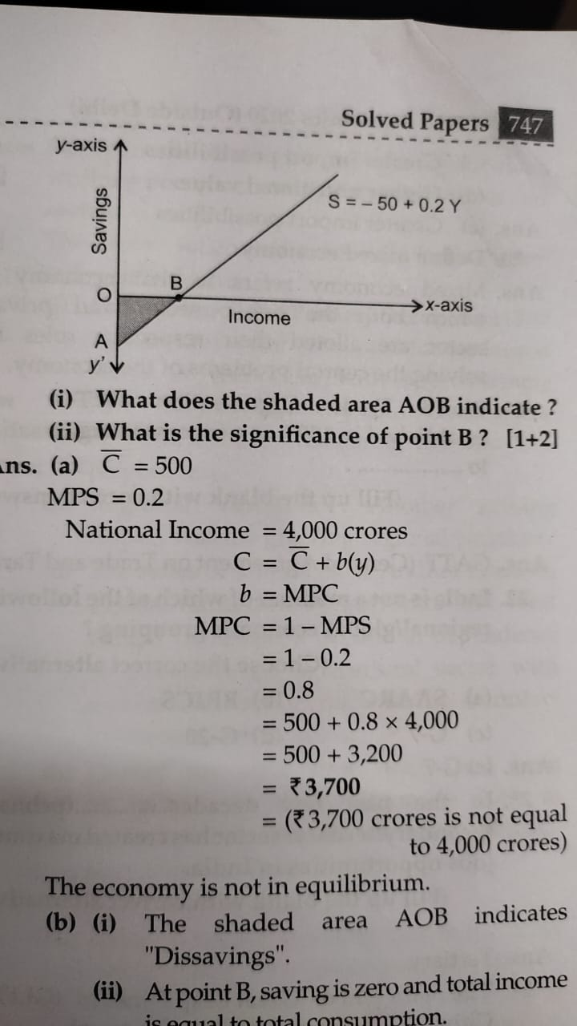

(i) What does the shaded area AOB indicate?

(ii) What is the significance of point B ? [1 + 2]

Ans. (a) C = 500

MPS = 0.2

National Income = 4,000 crores

C = C + b(y)

b = MPC

MPC = 1-MPS =1-0.2

= 0.8

= 500 + 0.8 X 4000

= 3,700

The economy is not in equilibrium.

(b) (i) The shaded area AOB indicates "Dissavings".

(ii) At point B, saving is zero and total income is equal to total consumption.

It means:

C = y

APC = C/y= y/y = 1

APS = 1 – APC = 1 – 1 = 0

APS = 0

Point B, average propensity to save is zero

73. In case of an underemployment equilibrium, which of the following alternative is not true?

(Choose the correct alternative).

(a) Aggregate demand is equal to Aggregate supply.

(b) There exist excess production capacity in the economy.

(c) Resources are not fully and efficiently utilised.

(d) Resources are fully and efficiently utilised.

Ans. (d) Resources are fully and efficiently utilised.

74. If Marginal Propensity to Save (MPS) is 0.25 and initial change in investment is 250 crores, then the final change in income would be ____________ (Choose the correct alternative).

(a) 1,000 crores

(b) 1,200 crores

(c) 500 crores

(d) 3,500 crores

Ans. MPS 0.25

Change in investment ∆ I =₹ 250 crore

Final change in income ∆ Y = ?

K = $\frac{∆ Y}{∆ I}$

K = $\frac{1}{MPS}$

= 1/0.25

K = 4

∆ Y = K X ∆I

= 4 X 250 crores

∆ Y= 1,000 crores

Change in income ∆ Y = 1,000 crores

(a) 1,000 crores

75. Why must aggregate demand be equal to aggregate supply at the equilibrium level of income and output? Explain with the help of a diagram.

Ans. According to Keynes, the equilibrium is reached only when aggregate demand (AD) equals aggregate supply (AS) because at this level there is no tendency for income and output to change.

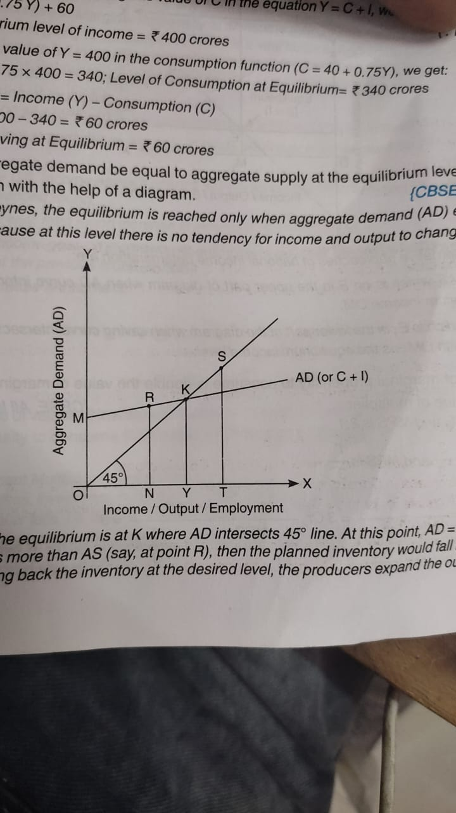

In the diagram the equilibrium is at K where AD intersects 450 line. At this point, AD = AS.

* When AD is more than AS (say, at point R), then the planned inventory would fall below the desired level. To bring back the inventory at the desired level, the producers expand the output. More output means more income. Rise in output means rise in AS and rise in income means rise in AD. Both continue to rise till they reach K, where AD = AS
* When AD is less than AS (say, at point S), then the planned inventory rises above the desired level. To clear the unwanted increase in inventory, firms plan to reduce the output till AD becomes equal to AS.

So, equilibrium takes place only at point K, when AD = AS

76. Explain national income determination through the two alternative approaches. Use diagram.

Ans. The national income determination can be better understood with the help of following diagram

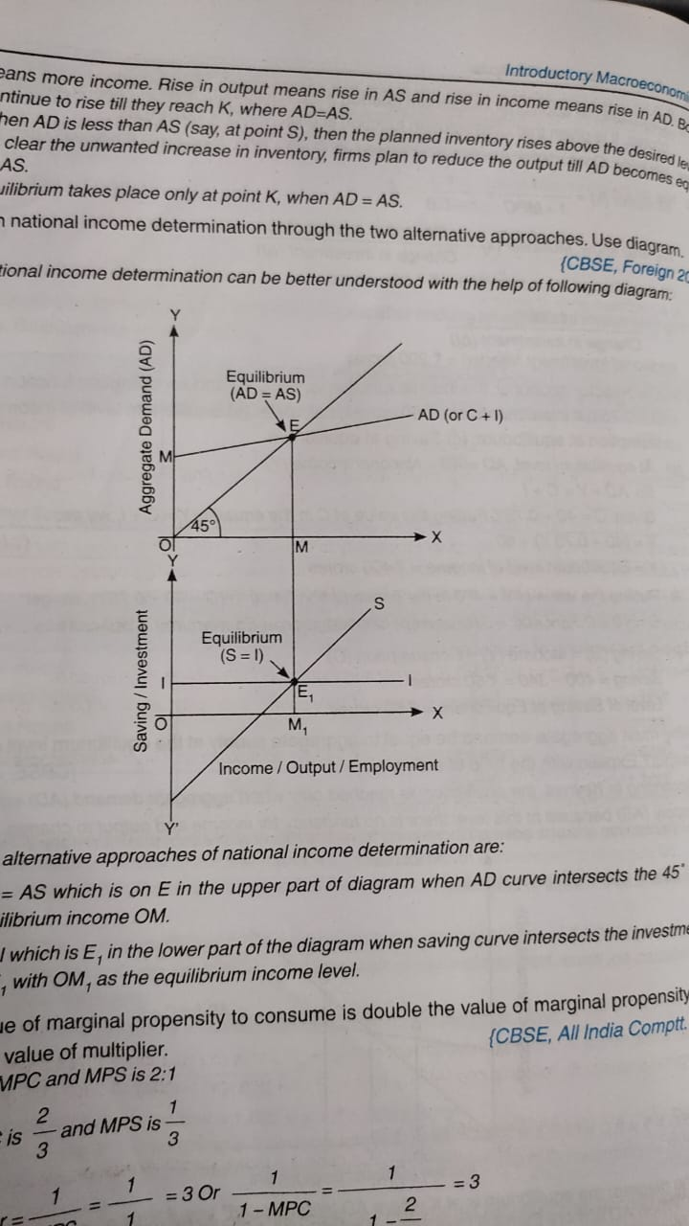

The two alternative approaches of national income determination are:

1. AD = AS which is on E in the upper part of diagram when AD curve intersects the 450 line with equilibrium income OM.

2. S = I which is E1 in the lower part of the diagram when saving curve intersects the investment curve at E1 with OM1 as the equilibrium income level.

77. The value of marginal propensity to consume is double the value of marginal propensity to save. Find the value of multiplier.

Ans. Ratio of MPC and MPS is 2:1

So, MPC is 2/3 and MPS is 1/3

Multiplier = 1/MPS = $\frac{1}{\frac{1}{3}}$ = 3 OR 1/1-MPC = $\frac{1}{1- \frac{2}{3}}$ = 3