INTRODUCTION
Q 1. Although water is useful, yet it is cheap. On the contrary, diamond is not much of use, still it is very expensive. Give an economic reason for this paradox.
Q 2. “Only scarce goods attract price.” Comment.
Q 3. “Scarcity and Choice go together”. Comment.
Q 4. Identify the following as Microeconomic study and Macroeconomic study:
- Production of a sugar mill
- Inflation rate
- Car industry
- Supply of money
- Wage determination in a company
- Allocation of resources
- Household expenditure
- Aggregate demand
- Foreign exchange rate
- Market demand for apples
Q 5. Identify the following as Positive Statements and Normative Statements:
- People should save more for their future.
- In India, pollution is increasing at an alarming rate.
- The Government should impose heavy taxes on rich people
- Smoking should be discouraged in the world.
- In India, tax rate slabs increase with increase in income.
- Higher interest rate induces people to save more out of their income.
- High taxes on cigarettes discourage smoking.
- Government should put more efforts to reduce pollution.
Q. 6. Identify and discuss the nature of the following newspaper reports in terms of positive or normative economic analysis:
- "India jumped 23 points in the World Bank's ease of doing business index to 77th place, highest in 2 years."-The Economic Times.
- "Government should further liberalise the business rules."-The Economic Times.
- The autonomy of the central bank of a country should be maintained as per the law.
- Nominal Gross Domestic Product (GDP) is calculated on the basis of 'current year prices'.
- Government should try to control the rising fiscal deficit.
- Real Gross Domestic Product (GDP) is calculated on the basis of 'base year price'.
- Consumer price index presents a more realistic picture of the inflation rate in a country, than the wholesale price index.
- Subsidies should be offered very carefully.

Q 7. Microeconomics is that part of economic theory which studies the behaviour of _______ units of an economy.
Q 8. Macroeconomics is also known as ________.
Q 9. ______________ is also known as Price Theory.
Q 10. ___________ is that part of economic theory which studies the behaviour of aggregates of the economy as a whole.
Q 11. __________ Economics deals with what are the economic problems and how are they actually solved.
Q 12. Two branches of Economics are ___________ and __________.
Q 13. The part of economics which deals with the question of what, how and for whom to produce is known as _____________.
Q 14. Macroeconomics deals with study of cotton textile industry.
Q 15. What does the slope of PPF indicate?
Q 16. "An economy always produces on, but not inside, a PPF, Defend or refute.
Q 17. A lot of people died and many factories were destroyed in an earthquake. How will it affect the PPF of the economy?
Q 18. Massive unemployment will shift the PPF to the left. Defend or refute.
Q 19. On the basis of given diagram, answer the following questions:
(i) On the production possibility curve AE, if the economy decides to produce 50 million tonnes of wheat, then how many tanks it can produce?
(ii) If there is growth in resources, what will happen to the production possibility curve?
(iii) Which point in the diagram represents underutilisation of resources?
(iv) Which of the points in diagram is an unattainable combination?
(v) Identify the point at which the economy will operate if resources are fully and efficiently utilised.
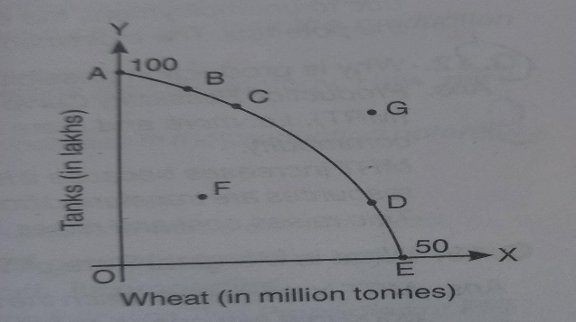
Q 20. Production in an economy is below its potential due to unemployment. Government starts employment generation schemes. Explain its effect using production possibilities curve.
OR
As a result of various programmes started by the government, more employment opportunities have been created. What will be its effect on production possibilities frontier? Explain.
Q 21. Why is production possibility curve concave? Explain.
Q 22. What is Marginal Rate of Transformation? Explain with help of an example.
Q 23. What will be the impact of recently launched ‘Clean India Mission' (Swachh Bharat Mission) on the Production Possibilities curve of the economy and why?
Q 24. What is likely to be the impact of efforts towards reducing unemployment on the production potential of the economy? Explain.
Q 25. What will be the impact of "Education for All campaign" (Sarv Shiksha Abhiyan) on the Production Possibilities Curve of the Indian economy and why?
Q 26. Explain the effects of floods in Jammu and Kashmir on its production possibilities frontier.
Q 27. Do rich countries also face central problems? Give reasons for your answer.
Answers
1. The economic reason for this paradox is scarcity. Although water is useful, yet it is cheap due to its abundance in the economy. Diamonds are very expensive because they are scarce and people are ready to pay a high price.
2. The given statement is correct. All resources are not scarce in the economy. For example, the air we breathe is abundant in relation to wants. Such goods are available free of cost. These goods are known as Non-Economic Goods. On the other hand, some goods are scarce in relation to their wants. For example, petrol, electricity, etc. are scarce in relation to wants. These goods command price and are known as Economic Goods. So, it is rightly said that only scarce goods attract price.
3. We live in a world of scarcity. All of us want better food, clothing, housing, schooling, entertainment, etc. But resources are not enough to meet all our wants. Even the richest economy (like U.S.A.) cannot satisfy all the needs of people. It means, scarcity of resources is a common feature of every economy and it gives rise to the problem of choice, i.e. how to make the best possible use of available resources. If resources were available in plenty, there would not have been any problem of choice. Hence, economics is concerned with the problem of choice under the conditions of scarcity.
4. Microeconomic Study: (i), (iii); (v), (vi), (vii); (x). Macroeconomic Study: (ii), (iv), (viii), (ix).
5. Positive Statements: (ii), (v), (vi); (vii); Normative Statements: (i), (iii), (iv), (viii).
6. Positive Statements: (i), (iv), (vi); (vii). Reason: It deals with a real life situation, justifiable by facts. Normative Statements: (ii), (iii), (v), (viii). Reason: It deals with a situation as it ‘ought to be’.
7. Individual
8. Income and Employment Theory
9. Microeconomics
10. Macroeconomics
11. Positive
12. Microeconomics
13. Microeconomics
14. False. Cotton textile industry is a micro concept as it is one of the part of industry. So, it is studied under microeconomics.
15. PPF is a downward sloping concave shaped curve.
- Its downward slope indicates that more of one good can be produced only by taking resources away from the production of another good.
- Its concave shape indicates that more and more units of one commodity have to be sacrificed to gain an additional unit of another commodity.
16. The given statement is refuted. An economy operates on PPF only when resources are fully and efficiently utilized. It means, if there is unemployment or inefficient use of resources, then the economy may operate inside the PPF. So, the economy may operate at point "H" (Fig. 1.14), in addition to the points on the curve AB on PPF.
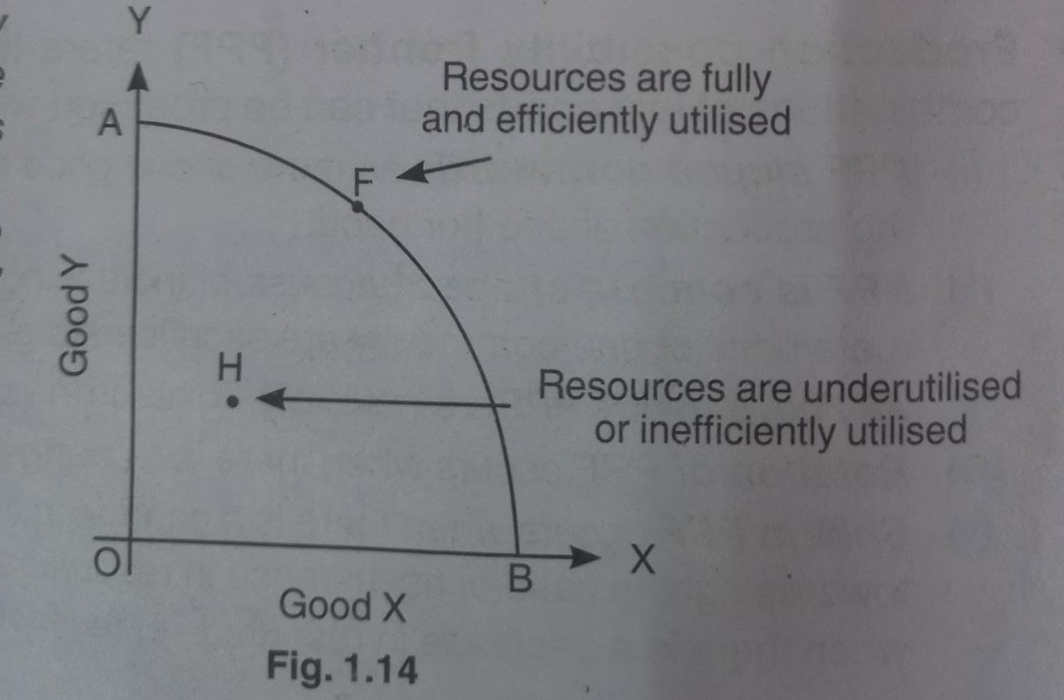
17. PPF of the economy will shift to the left from PP to P₁P₁, (refer Fig. 1.8). It happens because the number of possible combinations available with the economy has decreased, due to destruction of resources in the economy.
18. The given statement is refuted. Massive unemployment does not decrease the capacity of economy to produce. So, there will be no shift of PPE. However, economy will operate at some point inside the PPF, due to unutilisation of human resources.
19. (i) Zero Tanks.
(ii) The production possibility curve will shift towards right.
(iii) Point F
(iv) Point G.
(v) If resources are fully and efficiently utilized, then economy can operate at any point (like points A, B, C, D or E) on the production possibility curve.
20. Production below the potential means that total production in the economy is somewhere below the production possibility curve PP, for example at point U in the diagram.
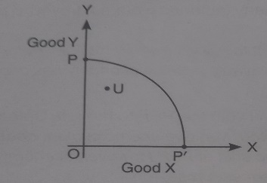
When government starts employment generation schemes, and since the below potential production is due to unemployment, the economy moves forward in its attempt to remove unemployment and reach the potential. The movement forward is towards the PP curve.
21. Production Possibility Curve is concave to the origin because of increasing marginal rate of transformation (MRT), more and more units of one commodity are sacrificed to gain an additional unit of another commodity.
MRT increases because it is assumed that no resource is equally efficient in production of all goods As resources are transferred from one good to another, less and less efficient resources have to be employed. This raises cost and raises MRT.
22. MRT is the rate at which the units of one good have to be sacrificed to produce one more unit of the other good in a two goods economy.
Suppose an economy produces only two goods X and Y. Further suppose that by employing these resources fully and efficiently, the economy produces 1X+ 10Y. If the economy decides to produce 2X it has to cut down production of Y by 2 units. Then 2Y is the opportunity cost of producing 1X. Then 2Y:1X is the MRT.
23. Cleanliness reduces chances of people falling ill and, thus can ensure better health. This in turn will reduce forced absenteeism from work, raise efficiency level and thus raise country's production potential. Rise in this potential shifts PP curve to the right.
24. Reducing unemployment has no effect on the production potential of the country. It is because production potential is determined assuming full employment.
Unemployment indicated that the country is operating below potential. Reducing unemployment simply helps in reaching potential.
25. Education raises efficiency by making a worker a skilled worker. This will increase production potential shifting the PP curve upwards.
26. Floods have damaged and reduced resources. Since potential production declines the production possibility frontier shifts to the left.
27. Yes, even in rich countries, resources are scarce, having alternative uses and wants are unlimited.

