**Foreign Exchange and B.O.P**

1. Other things remaining unchanged, when in a country the price of foreign currency rises, national income is:

(a) Likely to rise

(b) Likely to fall

(c) Likely to rise and fall both

(d) Not affected

Ans. (a) Likely to rise

2. Foreign exchange transactions dependent on other foreign exchange transactions are called:

(a) Current account transactions

(b) Capital account transactions

(c) Autonomous transactions

(d) Accommodating transactions

Ans. (d) Accommodating transactions

3. Other things remaining the same, when in a country the market price of foreign currency falls, national income is likely:

(a) to rise

(b) to fall

(c) to rise or to fall

(d) to remain unaffected

Ans. (b) to fall

4. What is the cause of devaluation of any country's currency?

(a) Increase in the domestic inflation rate

(b) Domestic real interest rates are less than foreign interest rates

(c) Much increase in the income

(d) All of these

Ans. (d) All of these

5. State whether the given statement is true or false.

'Managed Floating Exchange Rate is decided by market forces but remains within a specific range as decided by central bank.’

Ans. True. In this system, the central bank intervenes to minimise fluctuation in the exchange rate.

6. Name any two sources of demand for foreign exchange by households in an economy.

Ans. (a) Import of goods and services (b) Travel abroad

7. Define autonomous transactions in Balance of Payments of an economy.

Ans. Autonomous items refer to the international economic transactions which occur for achievement of economic motive such as profit maximization. These are independent of the country's BoP status.

8. Define accommodating transactions in Balance of Payments of an economy.

Ans. Accommodating items refer to the transactions which occur because of government financing. These are not independent of the country's BoP status.

9. Give the meaning of balance of payments.

Ans. Balance of Payments (BOP) records the transactions in goods, services and assets of the residents of a country with the rest of the world. It also records the country's demand for and supply of foreign exchange.

10. Give meaning of balance of trade.

Ans. Balance of trade refers to the relationship between the value of imports and exports of the goods of a country. It includes only visible items.

11. What is 'current account deficit' in the balance of payments?

Ans. Current account is said to be in deficit when the export of goods and services and unilateral transfers fall short of the import of goods and services and unilateral transfers.

12. What is 'devaluation'?

Ans. Devaluation is said to occur when the exchange rate is increased by the government under fixed exchange rate system.

13. What is 'managed floating exchange rate"?

Or

What is floating exchange rate?

Or

Give meaning of managed floating exchange rate.

Ans. It refers to a system in which foreign exchange rate is determined by market forces and central bank influences the exchange rate through intervention in the foreign exchange market.

14. How can increase in foreign direct investment affect the price of foreign exchange?

Ans. Increase in Foreign Direct Investment increases the supply of foreign exchange and hence, decreases the price of foreign exchange.

15. How can Reserve Bank of India help in bringing down the foreign exchange rate which is very high?

Ans. The Reserve Bank of India can sell foreign currency in exchange of domestic currency to bring down the foreign exchange rate.

16. What is a fixed exchange rate?

Ans. Fixed exchange rate refers to the rate of exchange which is fixed by the government.

17. Define foreign exchange rate.

Ans. Foreign exchange rate refers to the rate at which one currency is exchanged for the other. In other words, it is the price of one unit of the foreign currency in terms of the domestic currency.

18. State the components of capital account of balance of payments.

Ans. The main components of capital account are:

1. Borrowings and lendings to and from abroad: It includes:

* All transactions relating to borrowings from abroad by private sector, government, etc. Receipts of such loans and repayment of loans by foreigners are recorded on the positive (credit) side.
* All transactions of lending to abroad by private sector and government. Lending abroad and repayment of loans to abroad is recorded as negative or debit item.

2. Investments to and from abroad: It includes:

* Investments by rest of the world in shares of Indian companies, real estate in India, etc. Such investments from abroad are recorded on the positive (credit) side as they bring in foreign exchange.
* Investments by Indian residents in shares of foreign companies, real estate abroad, etc. Such investments to abroad are recorded on the negative (debit) side as they lead to outflow of foreign exchange.

3. Change in Foreign Exchange Reserves:

* The foreign exchange reserves are the financial assets of the government held in the central bank. A change in reserves serves as the financing item in India's BOP. So, any withdrawal from the reserves is recorded on the positive (credit) side and any addition to these reserves is recorded on the negative (debit) side. It must be noted that 'change in reserves' is recorded in the BOP account and not 'reserves

19. Define 'depreciation'.

Or

What is meant by depreciation of domestic currency?

Ans. Depreciation of domestic currency refers to decrease in the value of domestic currency in terms of foreign currency.

20. What is foreign exchange?

Ans. Foreign exchange refers to all currencies other than the domestic currency of a given country. For example, the US dollar is foreign exchange for India.

21. In recent times the Indian Rupee (₹) depreciated to an all-time low against the US dollar ($). Discuss its impact on India's Imports.

Or

When foreign exchange rate in a country is on the rise, what impact is it likely to have on imports and how?

Ans. An increase in the foreign exchange rate of domestic currency implies its depreciation. Depreciation of a currency implies a fall in the value of the domestic currency in terms of the foreign currency. The price of the domestic currency, in terms of a foreign currency, falls and the foreign exchange rate increases. For instance, suppose rupee has depreciated in terms of dollars. That is, the foreign exchange rate between India and the US has increased. The price of one dollar has increased from, say, ₹ 60 to ₹

22. It implies that Indian citizens can buy one-dollar worth of goods by parting ₹ 70 compared to ₹ 60 prior to rise in exchange rate. Since the US goods have become expensive for Indians, they will buy less of them. Consequently, Indian imports from the US will fall.

23. Name the broad categories of transactions recorded in the 'capital account' of the Balance of Payments Accounts.

Ans. The broad categories of transactions recorded in the 'capital account' of the Balance of Payments Accounts are:

(a) External assistance (b) Commercial borrowings

(c) NRI deposits (d) Foreign investment (e) Other flows

24. Name the broad categories of transactions recorded in the 'current account' of the Balance of Payments Accounts.

Ans. The main components of the current account of the Balance of Payments accounts include:

(a) Import and export of goods

(b) Import and export of services

(c) Unilateral transfers

The deficit in current account indicates that the current imports of goods and services and unilateral transfers to rest of the world are greater than the exports of goods and services and unilateral transfers from rest of the world.

25. What are fixed and flexible exchange rates?

Ans. Fixed exchange rate is the system in which the exchange rate is set and maintained by the government as official exchange rate. Flexible exchange rate is the system in which the exchange rate is determined by the demand and supply forces in the foreign exchange market.

26. Explain the meaning of managed floating exchange rate.

Or

Discuss briefly the concept of managed floating system of foreign exchange rate determination.

Ans. Managed floating exchange rate system is a mixture of a flexible exchange rate system (the float part) and a fixed rate system (the managed part). It is also known as dirty floating. Under this system, the central banks intervene to buy and sell the foreign currencies in an attempt to control the exchange rate movements whenever they feel that such actions are appropriate. Therefore, official reserve transactions are not equal to zero.

27. Where is 'borrowings from abroad' recorded in the Balance of Payments Accounts? Give reasons.

Ans. Borrowings from abroad would lead to inflow of foreign exchange into the country. Thus, borrowings from abroad will be recorded as positive items in the capital account of Balance of Payments.

28. Where will sale of machinery to abroad be recorded in the Balance of Payments Accounts? Give reasons.

Ans. Machinery is a visible item and its sale to abroad will be an export. This will result in Inflow of foreign exchange in the country. Thus, sale of machinery to abroad will be recorded as a credit item under visible items in the current account.

29. Define "Trade Surplus" and "Trade Deficit".

Ans. Trade surplus refers to a situation when value of exports of visible items exceeds the value of imports of visible items in the balance of payment account of a country. Trade deficit, on the other hand, refers to a situation when value of imports of visible items exceeds the value of exports of visible items in the balance of payment account of a country.

30. Visits to foreign countries for sightseeing, etc. by the people of India is on the rise. What will be its likely impact on foreign exchange rate and how?

Ans. Increase in the foreign visits of Indian residents would increase the demand for foreign currency. Since the supply of foreign currency remains the same, the foreign exchange rate would rise implying depreciation of rupee.

In the diagram, point E determines the equilibrium exchange rate in the foreign market (R*) and equilibrium quantity (Q*) of the foreign currency, where demand (DD) and supply (SS) curves intersect.

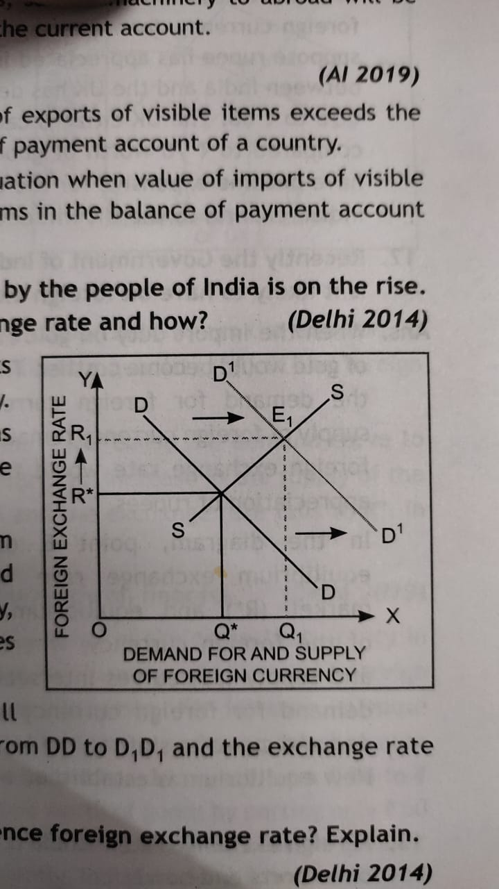

A rise in the demand for foreign currency will cause the demand curve to shift to the right from DD to D,D, and the exchange rate rises to R1.

31. How does giving incentives for exports influence foreign exchange rate? Explain.

Ans. The incentives for exports boost exports of the country. An increase in exports causes the supply of foreign currency to increase in the domestic country while the demand remains unchanged. Consequently, the exchange rate falls and the domestic currency appreciates.

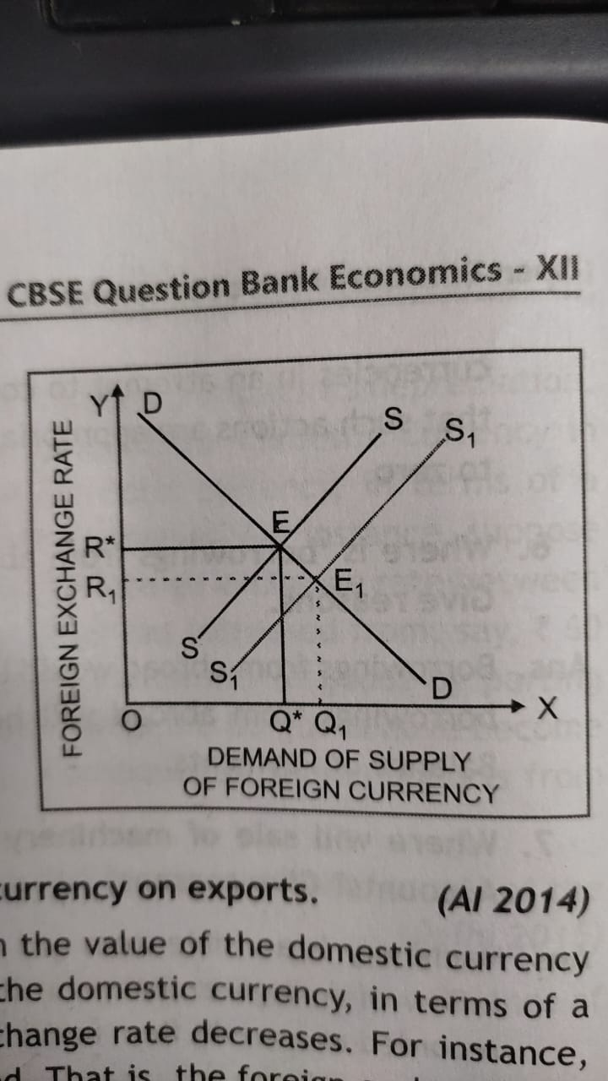

In the diagram, point E determines the equilibrium exchange rate in the foreign market ( R* ) and equilibrium quantity (Q*) of the foreign currency, where demand (DD) and supply (SS) curves intersect. A rise in the supply of foreign currency will cause the supply curve to shift to the right from SS to S1S1 and the exchange rate falls to R1.

32. Explain the effect of appreciation of domestic currency on exports.

Ans. Appreciation of a currency means an increase in the value of the domestic currency in terms of the foreign currency. The price of the domestic currency, in terms of a foreign currency, increases and the foreign exchange rate decreases. For instance, suppose rupee has appreciated in terms of pound. That is, the foreign exchange rate between India and the UK has decreased. The price of one pound has decreased from ₹ 70 to ₹ 60. The UK citizens can buy only ₹ 60 worth of goods by parting one pound compared to 70 worth of goods prior to fall in exchange rate. Since Indian goods have become expensive for the UK citizens, they will buy less of them. Consequently, Indian exports to the UK will decrease.

33. Recently the Government of India has doubled the import duty on gold. What impact is it likely to have on foreign exchange rate and how?

Ans. When the import duty on gold rises, the import of gold would become costlier. This would reduce the demand for foreign currency. Since the supply of foreign currency remains the same, the foreign exchange rate would fall. This implies appreciation of rupees.

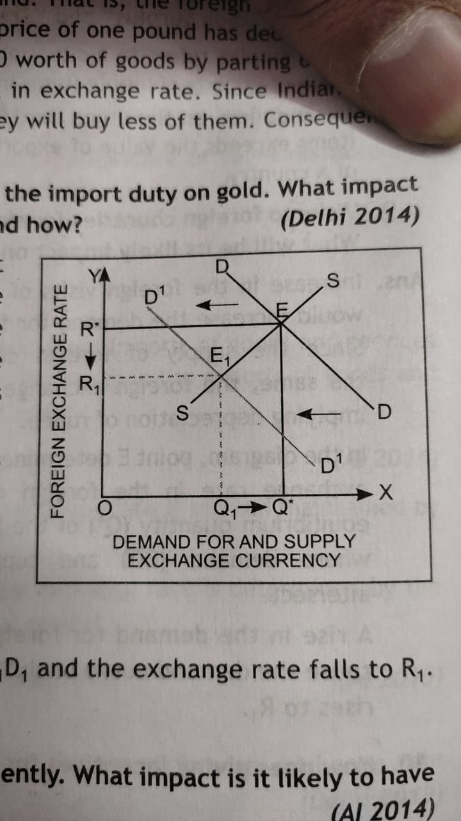

In the diagram, point E determines the equilibrium exchange rate in the foreign market (R*) and equilibrium quantity (Q*) of the foreign currency, where demand (DD) and supply (SS) curves intersect. A fall in the demand for foreign currency will cause the demand curve to shift to the left from DD to D1D1 and the exchange rate falls to R1. New equilibrium is established at E1.

34. Foreign exchange rate in India is on the rise recently. What impact is it on exports and how?

Or

Explain the effect of depreciation of domestic currency on exports.

Ans. Increase in the foreign exchange rate implies depreciation of domestic currency. As the price of the domestic currency in terms of a foreign currency decreases, the foreign exchange rate increases. For instance, suppose rupee has depreciated in terms of pound. That is, the foreign exchange rate between India and the UK has increased. The price of one pound has increased from ₹ 60 to ₹ 70. It implies that the UK citizens can buy ₹ 70 worth of goods by parting one pound compared to only ₹ 60 worth of goods prior to rise in exchange rate. Since Indian goods have become cheaper in the UK, they will buy more of them. Consequently, Indian exports to the UK will increase.

35. How is exchange rate determined in the foreign exchange market? Explain.

Ans. The exchange rate in the foreign market is determined by the intersection of supply and demand curves of the foreign exchange. The foreign exchange market, like any other normal market, comprises of a downward sloping demand curve and an upward sloping supply curve. In the following diagram, the vertical axis shows the price stated in terms of the domestic currency, that is, amount of rupee for one US dollar. The horizontal axis measures the quantity demanded or supplied.

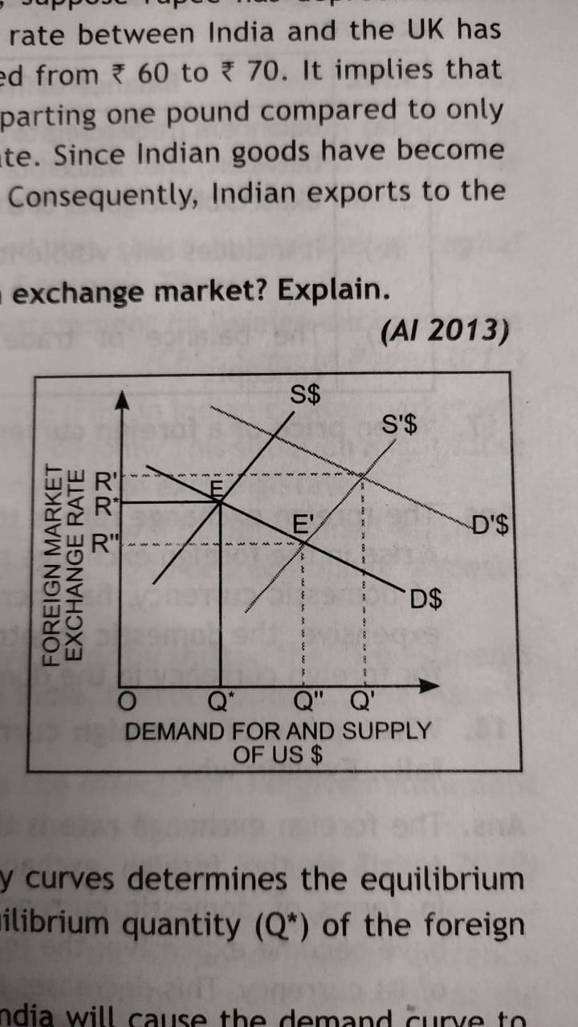

At point E, the intersection of demand and supply curves determines the equilibrium exchange rate in the foreign market (R*) and equilibrium quantity (Q*) of the foreign currency, that is, the US dollar ($).

An increase in the demand for the US dollars in India will cause the demand curve to shift to D'S and the exchange rate rises to R'. Similarly, an increase in the supply of the US dollars will cause the supply curve shift to S'$ and the exchange rate falls to R". In this case, the domestic currency is more valuable.

36. Explain the effect of appreciation of domestic currency on imports.

Ans. Appreciation of a currency means an increase in the value of the domestic currency in terms of the foreign currency. The price of the domestic currency, in terms of a foreign currency, increases and the foreign exchange rate decreases. For instance, suppose rupee has appreciated in terms of pound. That is, the foreign exchange rate between India and the UK has decreased. The price of one pound has decreased from ₹ 70 to ₹ 60. It implies that Indian citizens can buy one-pound worth of goods by parting only 60 compared to ₹ 70 prior to fall in exchange rate. Since UK goods have become cheaper for Indians, they will buy more of them. Consequently, Indian imports from the UK will Increase.

37. Distinguish between balance of trade and balance on current account.

Ans. Following are the points of difference between balance of trade and balance on current account:

|  |  |  |
| --- | --- | --- |
| S. No. | Balance of Trade | Balance on Current Account |
| (a)  (b)  (c) | Balance of trade refers to the relationship between the value of imports and exports of the goods of a country.  It includes only visible items.  The balance of trade is a narrow concept. | The current account balance is obtained by adding trade in services and net transfers to the trade balance.  It includes visible items, invisible items and transfers.  The current account balance is a broad concept. |

38. When price of a foreign currency rises, its demand falls. Explain why.

Ans. The foreign exchange rate is the price of one currency in terms of another currency. A rise in the foreign exchange rate implies that the price of foreign currency, in terms of domestic currency, has increased. Since foreign goods and services have become expensive, the domestic country can now buy less of them. This decreases the demand for foreign currency in the domestic country.

39. When price of a foreign currency falls, the supply of that foreign currency also falls. Explain why.

Ans. The foreign exchange rate is the price of one currency in terms of another currency. A fall in the foreign exchange rate implies that the price of foreign currency, in terms of domestic currency, has decreased. Since domestic goods and services have become expensive, the foreign country can now buy lesser quantity from one unit of its currency. This decreases the supply of foreign currency in the domestic country.

40. Distinguish between current account and capital account of the balance of payments account on the basis of its components.

Ans. The Balance of Payments on current account is the sum of balance of merchandise trade, services and net transfers received from rest of the world.

Items of Current Account

(a) Export and import of visible items or goods, i.e. goods like machinery, wheat, etc.

(b) Export and import of invisible items or services, i.e. banking, tourism, etc.

(c) Unilateral transfers are payments and receipts made by the residents of a country abroad.

(d) Private transfers in the form of gifts between domestic and foreign residents.

The Balance of Payments on capital account includes capital transactions relating to borrowing and lending of capital, sale and purchase of assets, interest payment, etc.

Items of Capital Account

(a) Private transactions that affect the assets or liabilities of individuals, business, etc.

(b) Official transactions that affect the assets and liabilities by the government and its agencies.

(c) Direct Investment in the form of purchasing an asset and at the same time acquiring control of it.

(d) Portfolio investment to acquire an asset that does not give the purchase control over the asset.

41. Explain the meaning of deficit in balance of payments.

Ans. When net balance of all the receipts and payment is negative, it is known as deficit in Balance of Payment (BoP). Deficit in BoP Indicates that all receipts are less than all the payments. These receipts and payments include both visible and invisible items.

42. "Foreign Institutional Investors (Flls) remained net seller in the Indian capital markets over the last few weeks". -The Economic Times

State and discuss the likely effects of the given statement on foreign exchange rate with reference to the Indian economy.

Ans. Selling of securities by Foreign Institutional Investors (FIls) in Indian capital market will result in fall in the supply of foreign currency in the economy. This situation might cause excess demand of foreign currency at the prevailing foreign exchange rate.

Consequently, a new equilibrium rate of foreign exchange will be determined which will be higher than the prevailing foreign exchange rate, leading to depreciation of domestic currency.

43. Many large Multinational Corporations (MNCs) have recently shifted their investments from China and have started their production in India, thereby boosting the Make in India plans of the government. Presuming other factors being constant, discuss the effects of the given statement on Foreign Exchange Rates with reference to the Indian Economy.

Ans. Investments by large multinational corporations (MNCs) in India will result in greater inflow of foreign exchange, leading to an increase in the supply of foreign currency.

Consequently, there will be excess supply of foreign currency in the economy at the prevailing foreign exchange rate.

A new equilibrium rate of foreign exchange will be determined which will be lower than the prevailing foreign exchange rate, leading to appreciation of domestic currency.

44. Discuss briefly the concept of flexible exchange rate system of foreign exchange rate determination.

Ans. In a system of flexible exchange rates, the exchange rate is determined by the free play of the market forces of demand and supply. Flexible exchange rate system is also known as the floating exchange rate. In a completely flexible system, the central banks do nothing to directly affect the level of the exchange rate. In other words, they I do not intervene in the foreign exchange market, and hence, there are no official reserve transactions. The equilibrium in the foreign exchange market may be shown with the help of a diagram.

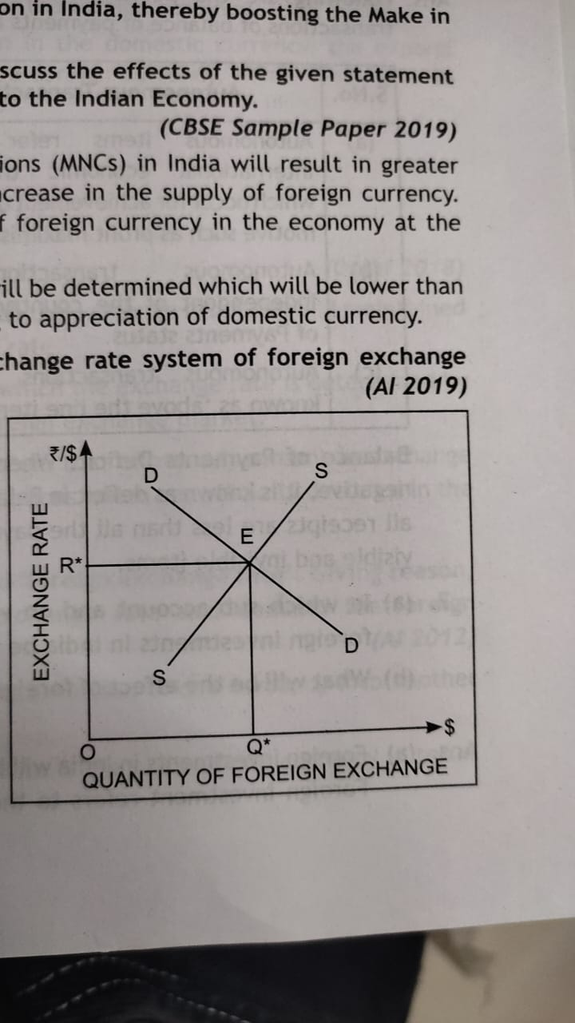

In the given figure, DD and SS are foreign exchange demand and supply curves respectively. DD and SS intersect at point E. Corresponding to this point, the equilibrium exchange rate is R* and the equilibrium quantity of foreign exchange is Q*.

45. Define "Trade surplus". How is it different from "Current account surplus"?

Ans. Trade surplus refers to excess of value of export of visible items over value of import of visible items in the balance of payment account of a country. In other words, it only includes trade of goods.

Current account surplus refers to excess of receipts from value of exports of visible items and invisible items; and unilateral transfers over payment for value of imports of visible items and invisible items; and unilateral transfer. It is a relatively broader concept as compared to trade surplus.

46. Why does the demand for foreign currency fall and supply rises when its price rises? Explain.

Ans. When price of foreign exchange rises, import becomes costlier, demand for imports will fall. As a result, demand for foreign currency falls.

When price of foreign exchange rises, domestic goods become cheaper for foreign buyers, because they can now buy more from one unit of foreign currency. As a result, demand for exports rise, leading to increase in supply of foreign exchange.

47. Visits to foreign countries for sightseeing etc. by the people of India is on the rise. What will be its likely impact on foreign exchange rate and how?

Ans. Visits to foreign countries will raise the demand for foreign exchange. Supply of foreign exchange remaining unchanged, exchange rate is likely to rise.

48. How does giving incentives for exports influence foreign exchange rate? Explain.

Ans. Incentives for exports are aimed at increasing exports. Increase in exports will bring more foreign exchange into the country. Demand for foreign exchange remaining unchanged, exchange rate is likely to fall.

49. Foreign exchange rate in India is on the rise recently. What impact is it likely to have on exports and how?

Ans. Rise in foreign exchange rate means that one unit of foreign currency is worth more rupees than earlier. So, one unit of foreign currency can now buy more goods and services from India. It makes Indian exports cheaper to the foreign buyers. This is likely to increase exports.

50. The central bank takes steps to control rise in the price of foreign exchange. Explain the economic values it involves as far as the common man is concerned.

Ans. Controlling rise in price of foreign exchange makes imports cheaper. The economic value is that common man now has to pay less for goods and services imported.

51. What will be the effect of foreign investments in India on exchange rate? Explain.

Ans Foreign investment adds to supply of foreign exchange. Demand remaining unchanged, it brings downward influence on the exchange rate.

52. Why are foreign exchange rate and supply of foreign exchange directly related? Explain.

Ans. When foreign exchange rate rises, domestic goods becomes cheaper for foreign buyers. This raises demand for exports, causing rise in supply of foreign exchange. Similarly, when foreign exchange rate falls, domestic goods become costlier for foreign buyers, decreasing demand for the exports, causing fall in supply of foreign exchange.

53. Devaluation and Depreciation of currency is one and the same thing. Do you agree? How do they affect the exports of a country?

Ans. Depreciation and Devaluation both imply a fall in external value of a currency, However, the term Depreciation is used under the floating exchange rate system, that is when the exchange rate system is determined by the combined market forces of demand and supply A. currency loses or gains value because of fluctuations in demand and supply.

The term 'Devaluation is used in a system of fixed exchange rates. In this system, the exchange value of a currency is decided by the govemment. Devaluation of currency is the deliberate action of the government.

Depreciation and Devaluation of a currency normally encourages exports from a country as exports become cheaper for the foreign nationals and foreign currency can now buy more of domestic goods, Le. the international competitiveness of the goods and services of such a nation gets better.

54. "Indian Rupee (Rs) plunged to all time low of 74.48 against the US Dollar ($)". -The Economic Times

In the light of the above report, discuss the impact of the situation on Indian Imports.

Ans. Indian rupee plunged to all time low of 74.48 against US dollar. It is called depreciation in the value of Indian Rupees. It may lead to fall in imports as foreign goods will become costlier for the domestic consumers.

55. "Foreign Institutional Investors (Flls) remained net seller in the Indian capital markets over the last O few weeks". -The Economic Times.

State and discuss the likely effects of the given statement on foreign exchange rate with reference to the Indian Economy.

Ans. Selling of securities by Foreign Institutional Investors (Fils) in Indian capital market will lead to fall in the supply of foreign currency in the economy. This situation might lead to excess demand of foreign currency at the prevailing foreign exchange rate.

As a result, a new equilibrium rate of foreign exchange will be determined, which will be higher than the prevailing foreign exchange rate, leading to depreciation of domestic currency.

56. ‘Many large Multinational Corporations (MNCs) have recently shifted their investments China and have started their production in India, thereby boosting the Make in India plans of the government.’

Presuming other factors being constant, discuss the effects of the given statement on Foreign Exchange rates with reference to the Indian Economy.

Ans. Investments by large multinational corporations (MNCs) in India will ensure greater inflow of foreign exchange, leading to an increase in the supply of foreign currency. This situation may result into excess supply of foreign currency in the economy at the prevailing foreign exchange rate. As a result, a new equilibrium rate of foreign exchange will be determined, which will be lower than the prevailing foreign exchange rate, leading to appreciation of domestic currency

57. Are the following entered (i) on the credit side or the debit side and (ii) in the current account or capital account in the Balance of Payments account? You must give reason for your answer.

(a) Investments from abroad.

(b) Transfer of funds to relatives abroad.

(c) Imports of machinery.

(d) Interest on loan received from Nepal.

(e) Import of mobile phones from China.

Ans. (a) Investments from abroad: It is recorded in capital account because it creates a liability to pay foreign exchange. It is recorded on credit side because it leads to inflow of foreign exchange.

(b) Transfer of funds to relatives abroad: It is recorded in the current account because it does not change any liability or an asset. It is recorded on debit side because it leads to outflow of foreign exchange.

(c) Imports of machinery: It is recorded as visible items in the current account because it does not change any liability or an asset. It is recorded on debit side because it leads to outflow of foreign exchange.

(d) Interest on Loan received from Nepal: It will be recorded on the credit side of the current account as it brings in funds to the country.

(e) Import of mobile phones from China: It will be recorded in the debit/payment side of the current account as it is represents outflow of the foreign currency through visible imports.

58. Distinguish between current account and capital account of the balance of payments account on the basis of its components.

Ans. The current account of BOP records: Exports and imports of goods, Exports and imports of services, Income receipts and payments and Transfer receipts and payment.

On the other hand, Capital Account records: Borrowings from and to abroad, Investments from and to abroad and Decrease and increase in foreign exchange reserves.

59. Where will sale of machinery to abroad be recorded in the Balance of Payments Accounts? Give reasons.

Ans. Sale of machinery to abroad is export of goods and thus recorded in the Current Account. As it brings in foreign exchange, it is recorded on the credit side.

60. Where is 'borrowings from abroad' recorded in the Balance of Payments Accounts? Give reasons.

Ans. Borrowings from abroad' is recorded in the 'capital account' of BOP account because it increases international liability of the country. It is recorded on the credit side because it brings in foreign exchange into the country.

61. Giving reasons explain where charity to foreign countries is recorded in the Balance of Payments Accounts.

Ans. Charity to foreign countries is recorded in the current account of BOP account because it is a transfer payment. It is recorded on the debit side because it leads to outflow of foreign exchange.

62. In which sub-account and on which side of balance of payments account, will foreign investments in India be recorded? Give reasons.

Ans. Foreign investment will be recorded in the capital account of the balance of payments account because these give rise to foreign exchange liabilities. Foreign investment will be recorded on the credit side because these bring in foreign exchange to the economy.

63. Indian investors lend abroad. Answer the following questions:

(a) In which sub-account and on which side of the Balance of Payments Account such lending is recorded? Give reasons.

(b) Explain the impact of this lending on market exchange rate.

Ans: (a) Indians lending abroad is recorded in capital account of Balance of Payments account because it leads to creation of foreign exchange assets. It is recorded on the debit side because it leads to outflow of foreign exchange

(b) Lending abroad increases demand for foreign exchange. Supply of foreign exchange remains unchanged; exchange rate may rise.

64. Government takes measures to restrict autonomous imports of gold. Explain the economic values desired to be achieved from this.

Ans. Restricting autonomous imports of gold will reduce the foreign exchange demand. It will reduce the foreign exchange payments. Since autonomous payments decline, BOP deficit will decline. This decline will reduce pressure of deficit and it is the economic value realised.

65. What will be the effect of the following on the Balance of Payments: (i) "Make in India' Programme; (i) Import of Pulses.

Ans. (i) ‘Make in India' will increase supply (inflow) of foreign exchange in India, causing improvement in the balance of payments position.

(ii) Import of pulses will lead to outflow of foreign exchange from the country, causing adverse effect on balance of payment position.

66. State the effect of rise in the price of foreign currency on the Balance of Payments situation.

Ans. Rise in price of foreign currency will make imports costlier. So, imports will fall and it will be favorable for Balance of Payments as demand for foreign exchange will fall.

67. According to recent media reports: 'USA has accused China of currency devaluation to promote its exports.’ In the light of the given media report comment, how exports can be promoted through the Currency devaluation?

Ans. USA has a valid point of argument as devaluation of a currency encourages exports of a country. As exported goods become cheaper in the international market giving a competitive edge for the goods of domestic country (China). Devaluation of the value of domestic currency promotes the exports of the country and may adversely impact the production and sale of importing country (USA).

68. What is meant by Current Account Deficit (CAD) and Current Account Surplus (CAS)? State their significance.

Ans. Current Account Deficit (CAD) is a situation that arises when the receipts on current account are less than the payments on current account. In simple words, Current Account Deficit (CAD) arises when the value of exports of goods and services is less than the value of imports of goods and services. Current Account surplus (CAS) is a situation that arises when the receipts on current account is more than the payments on current account. In simple words, Current Account Surplus (CAS) arises when the value of exports of goods and services is more than the value of imports of goods and services.

CAD signifies that the nation is a borrower from rest of the world, whereas, CAS signifies that the nation is a lender to the rest of the world.

69. Calculate the current account balance from the following information:

|  |  |
| --- | --- |
| Particulars | (₹ in crores) |
| (i) Export of visible items  (ii) Import of invisible items  (iii) Import of visible items  (iv) Export of invisible items  (v) Gifts and transfers from rest of the world | 125  70  90  95  25 |

Ans. Current Account Balance = (Export of visible items-Import of visible items) + (Export of invisible items-Import of invisible items) + Gifts and transfers from rest of the world

= (125 - 90) + (95 - 70) + 25 = ₹ 85 crores.

70. Which transactions determine the balance of trade? When is balance of trade in surplus?

Ans. There are only two transactions which determine the balance of trade. These are payments made and received on account of export and import of goods or visible items. Balance of trade will be in surplus when the export value of goods exported is more than the value of goods imported.

71. Define "Trade surplus". How is it different from "Current account surplus"?

Ans. Trade surplus refers to excess of value of export of visible items over value of import of visible items in the balance of payment account of a country.

Current account surplus refers to excess of receipts from value of export of visible items, invisible items and unilateral transfers over payments for value of import of visible items, invisible items and unilateral transfers. It is relatively broader concept as compare to trade surplus.

72. "A country with trade deficit cannot have current account surplus in its Balance of Payments? Do 0 you agree with the given statement? Discuss with reason.

Ans. No, trade deficit occurs when value of goods/visibles imported is more than the value of goods/visibles exported.

Trade Deficit = Value of Imports < Value of Exports

Trade Surplus in this situation will arise when the deficit on trade account is less than the surplus on account of invisibles.

**State True of false:**

1. Excess of foreign exchange receipts over foreign exchange payments on account of accommodating transactions equals deficit in the balance of payments.

False. Excess of foreign exchange payments over foreign exchange receipts on account of autonomous transactions leads to deficit in the balance of payments.

2. Export and import of machines are recorded in capital account of the balance of payments account.

False. It will be recorded in the current account of the balance of payments account.

3. Current account of Balance of Payments account records only exports and imports of goods and services.

False. In addition to exports and imports of goods and services, current account also records unilateral receipts and payments.

4. Foreign investments are recorded in the capital account of balance of payments.

True. Foreign investments are recorded in the capital account of balance of payments as such investments cause a change in the assets of the country.

5. Profits received from investments abroad is recorded in capital account

Ans. It is recorded in current account as it neither affects foreign exchange assets nor foreign exchange Stabilities.

6. Import of machines is recorded in current account.

True. All imports and exports of goods are recorded in trade account which is a part of current account, because it is simply import/export of a good.

**Long Answer Type Questions (6 marks)**

1. Explain the distinction between autonomous and accommodating transactions in balance of payments. Also explain the concept of balance of payments 'deficit' in this context.

Ans. Following are the points of difference between autonomous and accommodating transactions of balance of payments account:

|  |  |  |
| --- | --- | --- |
| S. No. | Autonomous Transaction | Accommodating Transactions |
| (a)  (b)  (c) | Autonomous items refer to the international economic transactions, which occur for achievement of economic motive such as profit maximization.  Autonomous transactions are independent of the country's Balance of Payments status.  Autonomous transactions are also known as 'above the line items'. | Accommodating items refer to the transactions, which occur because of government financing.  Accommodating transactions are not independent of the country's Balance of Payments status.  Accommodating transactions are also known as 'below the line items'. |

Balance of Payments Deficit: When net balance of all the receipts and payment is negative, it is known as deficit in Balance of Payment (BOP). Deficit in BoP indicates that all receipts are less than all the payments. These receipts and payments include both visible and invisible items.

2. (a) In which sub-account and on which side of balance of payments account will foreign investments in India be recorded? Give reasons.

(b) What will be the effect of foreign investments in India on exchange rate? Explain.

Ans. (a) Foreign investments in India will be recorded on credit side of BOP's Capital account. Foreign investment refers to the investment in the assets owned by the foreign country. By investing in foreign assets, the resident of domestic country owns: the control over it in the foreign country. Moreover, foreign investment leads to an inflow of foreign exchange into the country and hence, it is recorded as positive items in the BoP's Capital Account.

(b) Foreign investments in India will increase the supply of foreign currency. A rise in the supply of foreign currency will cause the supply curve to shift to the right from SS to S,S, and the exchange rate falls to R,.

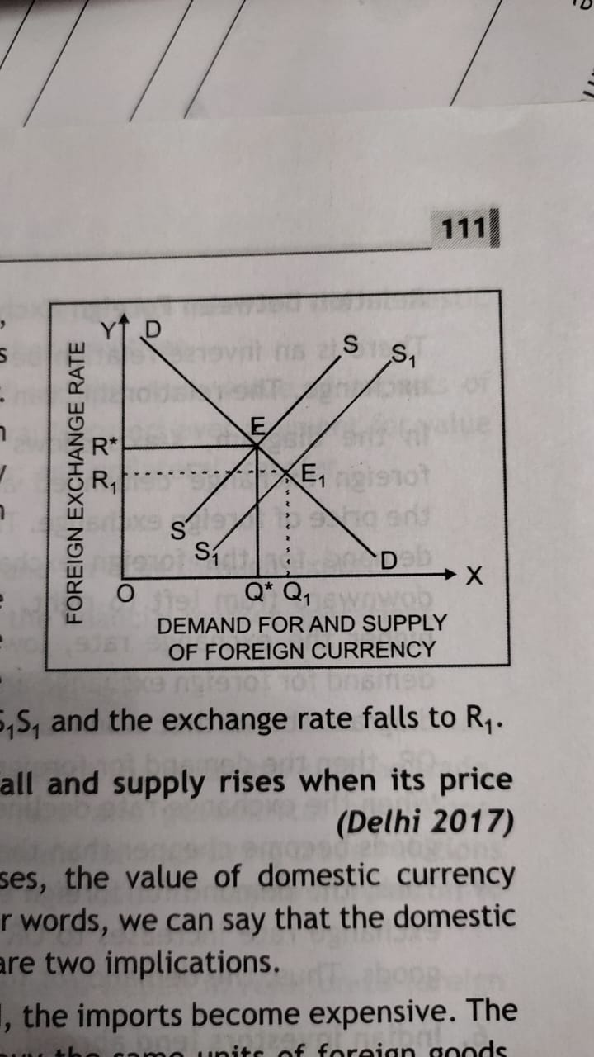

3. Why does the demand for foreign currency fall and supply rises when its price rises? Explain.

Ans. When the price of the foreign currency increases, the value of domestic currency Increases in terms of the foreign currency. In other words, we can say that the domestic currency depreciates. Now in such a case, there are two implications.

(a) Since the domestic currency has depreciated, the imports become expensive. The domestic traders will have to pay more to buy the same units of foreign goods.

This leads to a decline in the demand for the foreign currency.

(b) At the same time, with a depreciation in the domestic currency, the exports become cheaper. This will bring in more foreign currency, hence leading to an increase in the foreign exchange supply.

3. Discuss briefly the meanings of:

(a) Fixed Exchange Rate

(b) Flexible Exchange Rate

(c) Managed Floating Exchange Rate

Ans. (a) Fixed exchange rate is the system in which the exchange rate is set and maintained by the government as official exchange rate.

(b) Flexible exchange rate is the system in which the exchange rate is determined by the demand and supply forces in the foreign exchange market.

(c) Managed floating exchange rate is a system that allows adjustment in exchange rate according to a set of rules and regulations which are officially declared in the foreign exchange market..

4. Give the meaning of 'foreign exchange' and 'foreign exchange rate'. Giving reason, explain the relation between foreign exchange rate and demand for foreign exchange.

Ans. Foreign Exchange: Foreign exchange is the conversion of one currency into another currency.

Foreign Exchange Rate: Foreign exchange rate is the price of one currency in terms of another currency.

Relation between Foreign Exchange Rate and Demand for Foreign Exchange

There is an inverse relation between foreign exchange rate and demand for foreign exchange. The relationship can be explained with the help of a diagram.

In the diagram, X-axis shows the quantity of foreign exchange demanded and Y-axis shows the price of foreign exchange. The curve showing demand for the foreign exchange (DD) slopes downward from left to right. This implies that higher the exchange rate, lower would be the demand for foreign exchange and vice-versa. The diagram shows that when the exchange rate is OR, then the demand for foreign exchange is OQ. When the exchange rate declines to OR", foreign goods become cheaper than the domestic goods. Thus, the demand for foreign exchange increases to OQ’. On the contrary, when the exchange rate increases to OR', foreign goods become expensive than the domestic goods. Thus, the demand for foreign exchange decreases to OQ".

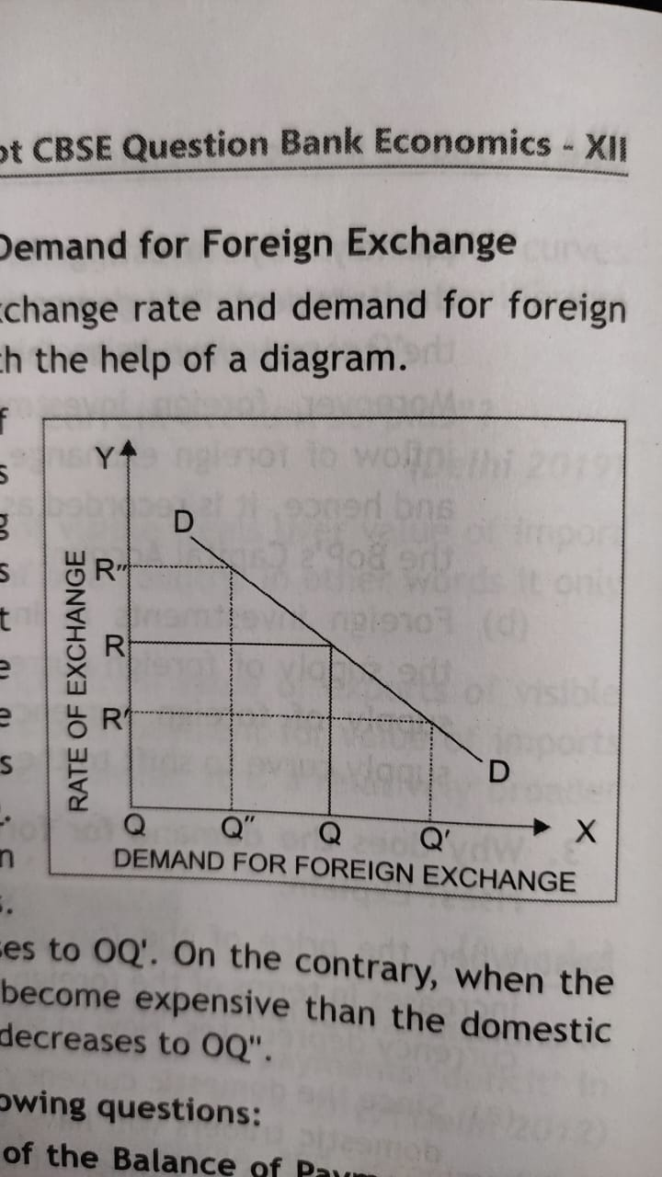

5. Indian investors lend abroad. Answer the following questions:

(a) In which sub-account and on which side of the Balance of Payments account such lending is recorded? Give reasons.

(b) Explain the impact of this lending on market exchange rate.

Ans. (a) Lending abroad by Indian investors will be recorded on debit side of BoP's Capital account. Indian investors' lending abroad leads to an outflow of foreign exchange from domestic territory. Hence, it will be recorded as negative item in the of BoP's Capital Account.

(b) Lending to abroad by Indian investors will decrease the supply of foreign currency. A fall in the supply of foreign currency will cause the supply curve to shift to the left from SS to S1S1 and the exchange rate rises to R1.

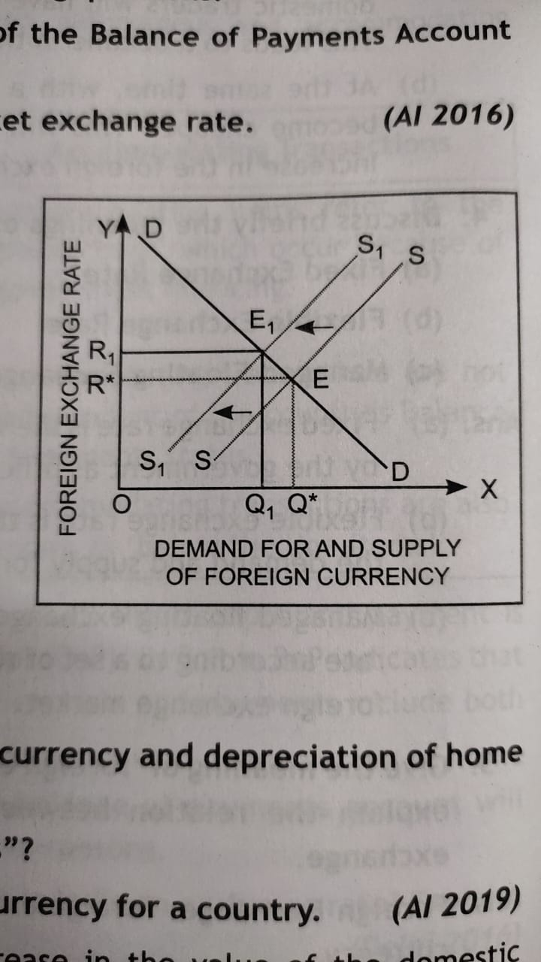

6. (a) Distinguish between appreciation of home currency and depreciation of home currency.

(b) What is meant by "current account surplus"?

(c) State any one source of supply of foreign currency for a country.

Ans. (a) Appreciation of home currency means increase in the value of the domestic currency in terms of the currencies of the other countries. On the other hand,

depreciation of home currency means lowering of the value of the domestic currency in terms of the currencies of the other countries.

(b) Current account surplus refers to excess of receipts from value of exports of visible items and invisible items; and unilateral transfers over payment for value of imports of visible items and invisible items; and unilateral transfer.

(c) Sources of Supply of Foreign Exchange

* Foreigners purchasing home country's goods and services through exports
* Foreign Investment in home country through the financial market operations